

**Server & Cloud Security**

**SCHOOL OF INFOCOMM TECHNOLOGY**

Diploma in Cyber Security & Forensics

Diploma in Information Technology

**INDIVIDUAL ASSIGNMENT**

**Duration:** Weeks 5 -17

**Weightage:** 15% out of Total 30%

**Tutorial Group: P03 Team Number:_____**

|  |  |
| --- | --- |
| **Student Name** | **Student Number** |
| Neo Rei Siang Edward | S10204829 |

# SCS Individual Assignment

**SCS Individual Assignment** **1**

**1. Install Necessary Server Roles and Remove Unnecessary Server Roles** **2**

**2. Creating Share Folder** **3**

**3. Testing of Shared Folder** **8**

**4. Hardening File Server** **10**

4.1 Configure Quota Limit 10

4.1.1 Setting Up the Quota Limit 10

4.1.2 Testing Quota Limit 15

4.1.2.1 File Larger Than 100 MB 15

4.1.2.2 Exceed Percentage Threshold 16

4.2 Configure File Screens 18

4.2.1 Setting Up File Screens 18

4.2.1 Testing File Screens Implemented 20

4.3 AntiVirus 22

4.3.1 Setting Up Windows AntiVirus 22

4.3.2 Testing Windows AntiVirus 23

4.4 Host Firewall 24

4.4.1 Setting Up Windows Firewall 24

4.4.2 Testing Host Firewall 26

4.5 Host Intrusion Detection / Prevention System(IDS/IPS) 29

4.5.1 Setting Up Snort 29

4.5.2 Testing Snort 37

4.6 Encryption 42

4.6.1 Installing Bitlocker 43

4.6.2 Testing of BitLocker Encryption 50

4.6.3 Setting Up 7-Zip Encryption 52

4.6.4 Testing of 7-Zip Encryption 54

4.7 Configure Access Control List 61

4.7.1 Configure Access Control List 61

4.7.2 Testing Access With Created Users 72

4.8 Server Backup 74

4.8.1 Server Backup Implementation 74

4.8.2 Testing Server Backup 83

4.9 Account Lockout Policy 84

4.9.1 Implementation of Account Lockout Policy 84

4.9.2 Testing of Account lockout Policy 88

4.10 Logging 89

4.10.1 Implementation of Logging on Shared Folder 89

4.10.2 Testing of Implemented Logging 92

4.10.2.1 Accessing Network Shared Object 92

4.10.2.2 Opening of File in Shared Folder 93

4.10.2.3 Deleting of File in Shared Folder 94

4.10.2.4 Modification of File in Shared Folder 95

4.10.2.5 Closing of File in Shared Folder 96

4.11 Ensuring OS is the latest version 98

4.12 Changing of Default User Account Names and Passwords 99

4.12.1 Implementing Change of Default User Account Names and Passwords 99

4.12.2 Testing of Changed Default Name 103

**5. Conclusion** **105**

# 1. Install Necessary Server Roles and Remove Unnecessary Server Roles

In order to set up the file server, the MS1 virtual machine was duplicated. This was done to save time since there will not be a need to reconfigure the file server to connect to a new domain in which the domain controller is in. After duplicating the MS1 virtual machine, it was named as “SCS ASG File System”. Then, File and Storage Service, File and iSCSI Services, and File Server Resource Manager were installed on the server. These roles needed to be installed as they are essential in helping the server become a file server. The server role, “Web Server” was also removed from the server since it is unnecessary.

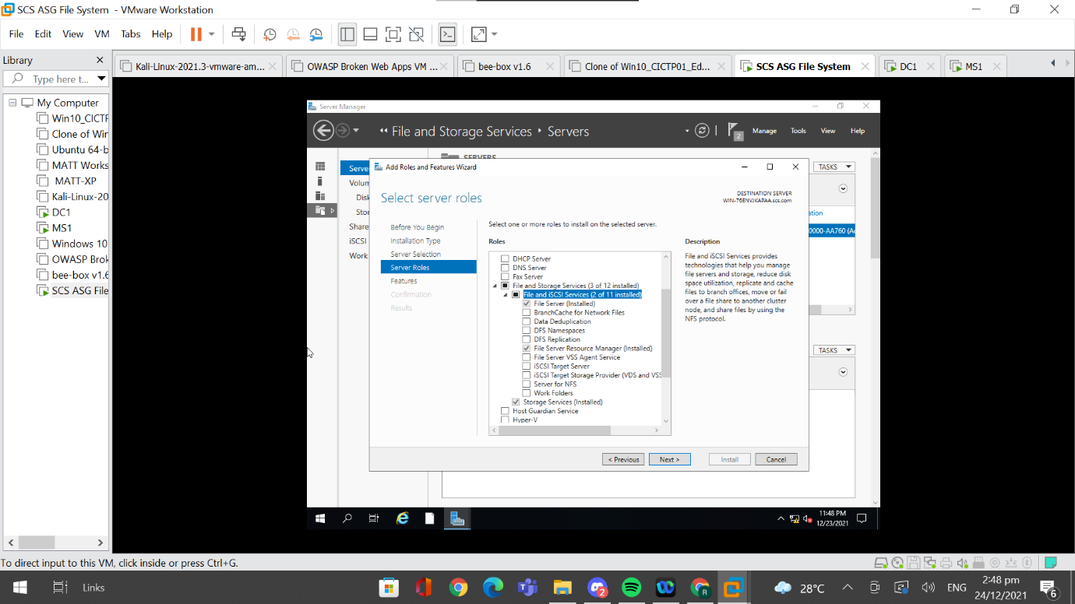

# 2. Creating Share Folder

As the server will be a file server, I have to create a share folder so that users in the domain can have a centralised location for storing and sharing work related files. In order to create a share folder I first have to go to server manager, to File and Storage Services, to Shares. Then, I have to right click an available space and click on New Share.

Next, I have to configure the shared folder. Firstly, to set the profile of the share folder, I chose “SMB Share - Advanced”.

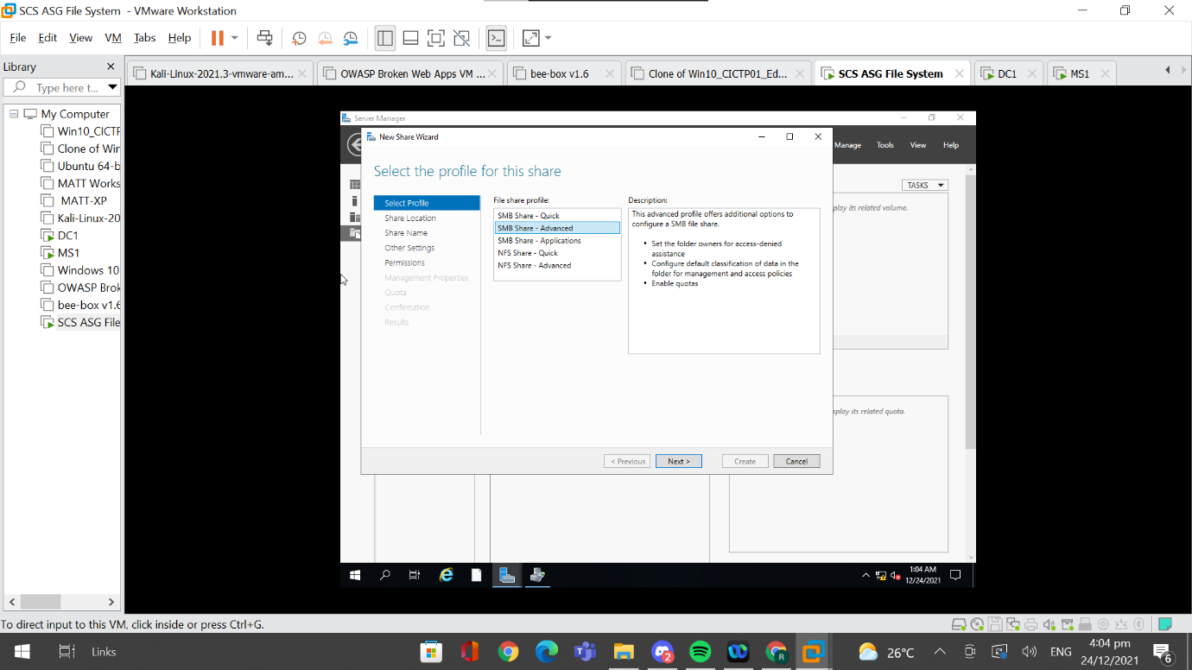

Secondly, I chose the location of the shared folder to be stored on. I decided to store it in the C: Drive.

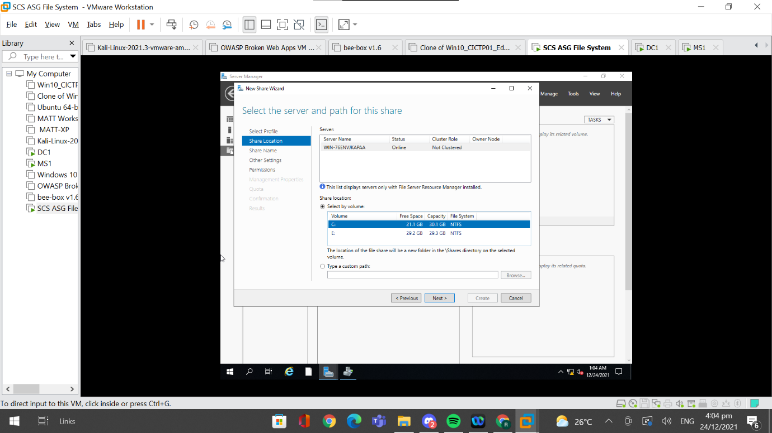

Thirdly, I gave the folder an appropriate name and specified the path location of the shared folder. I named the folder as “SCS_ASG_Share_Folder” and specified the path location to be “C:\Shares\SCS_ASG_Share_Folder”.

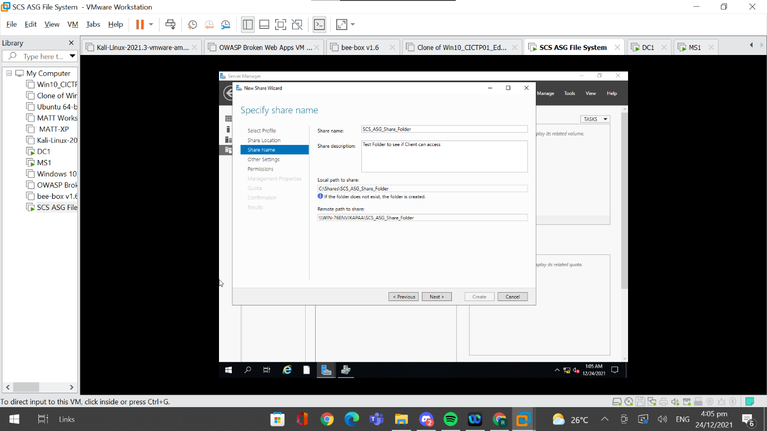

Fourthly, I enabled other settings such that if the user does not have read permissions of a file in the shared folder, the file will not display and remote file access is also encrypted which makes it more secure against unauthorized access.

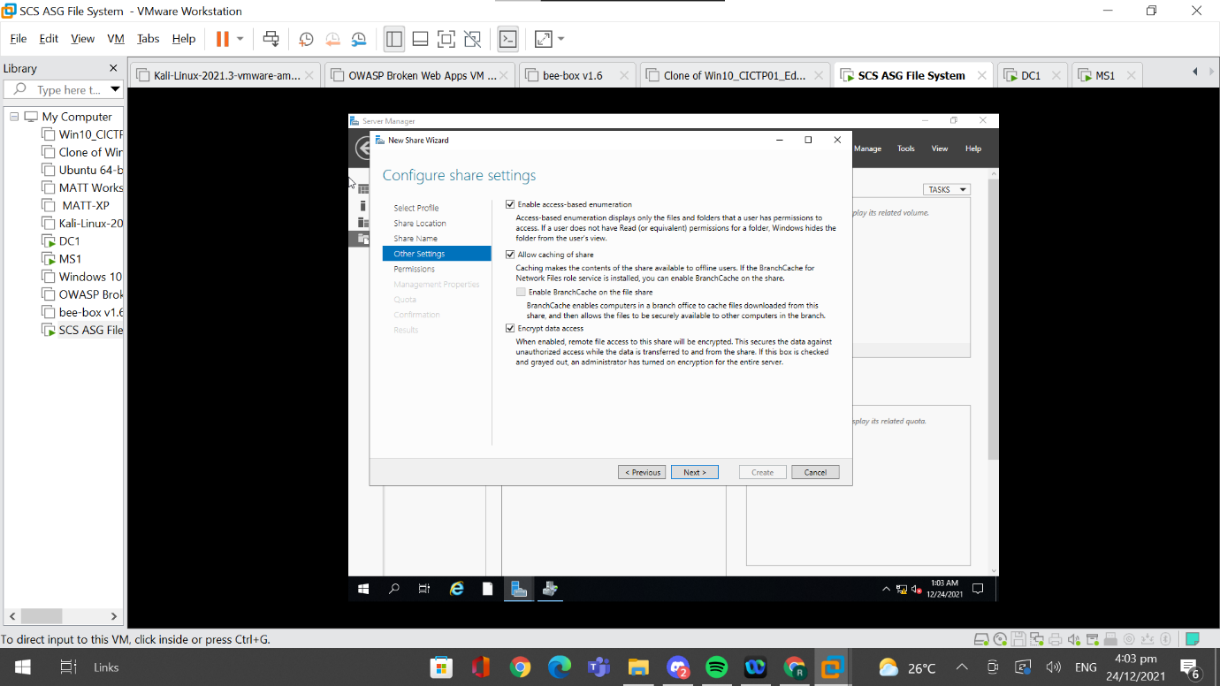

For the fifth option, the access control list can be customised here, but I left it as default as I will be using the domain controller to set up the access control list later.

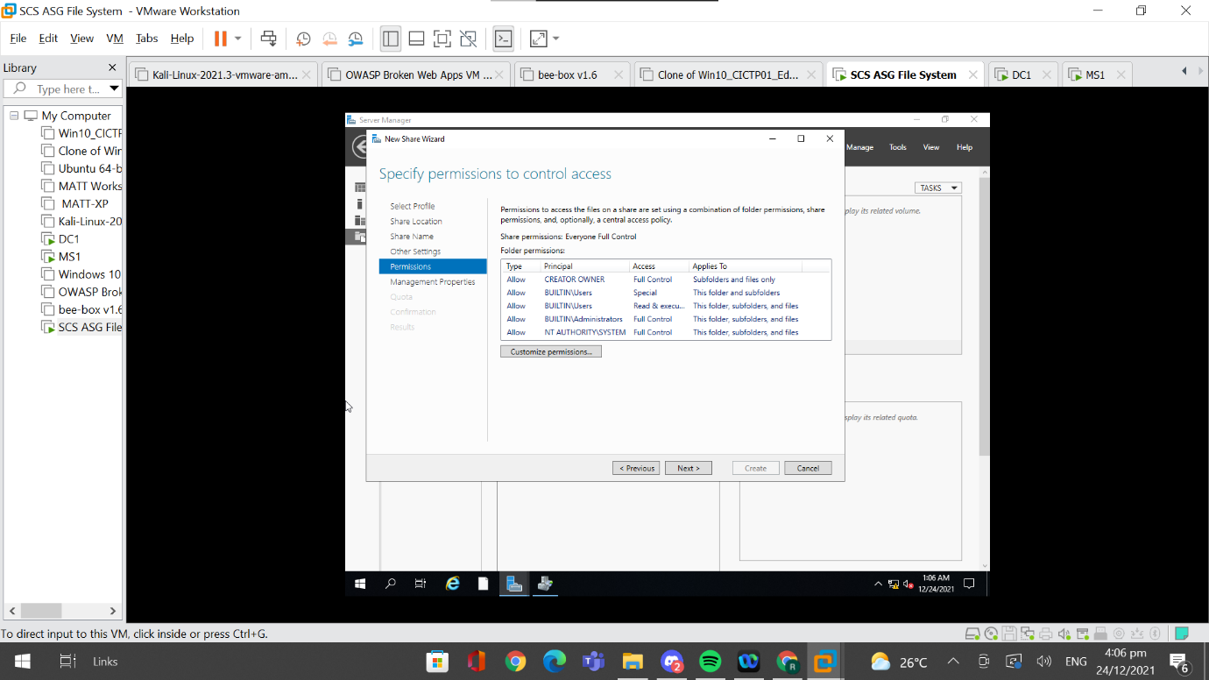

For the sixth option, I chose Group File as its folder usage because multiple users will be accessing the folder.

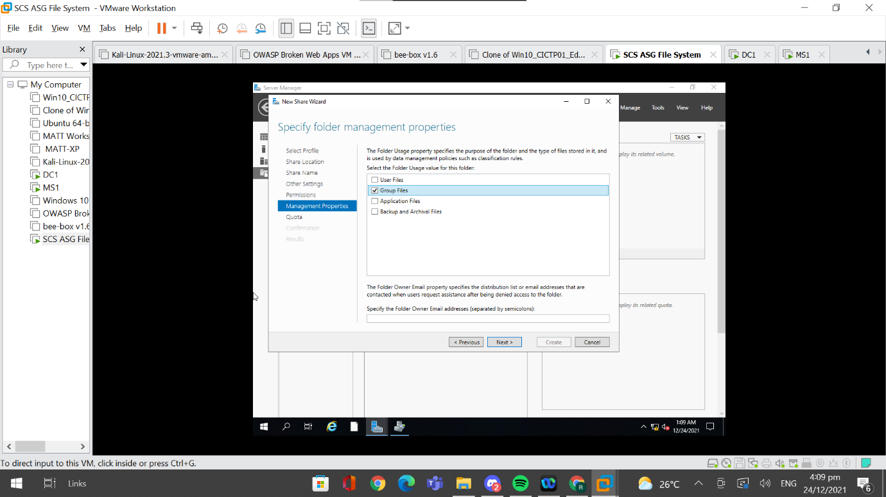

Lastly, I chose to not apply a quota to the shared folder for now and will adjust it manually later using file server resource manager.

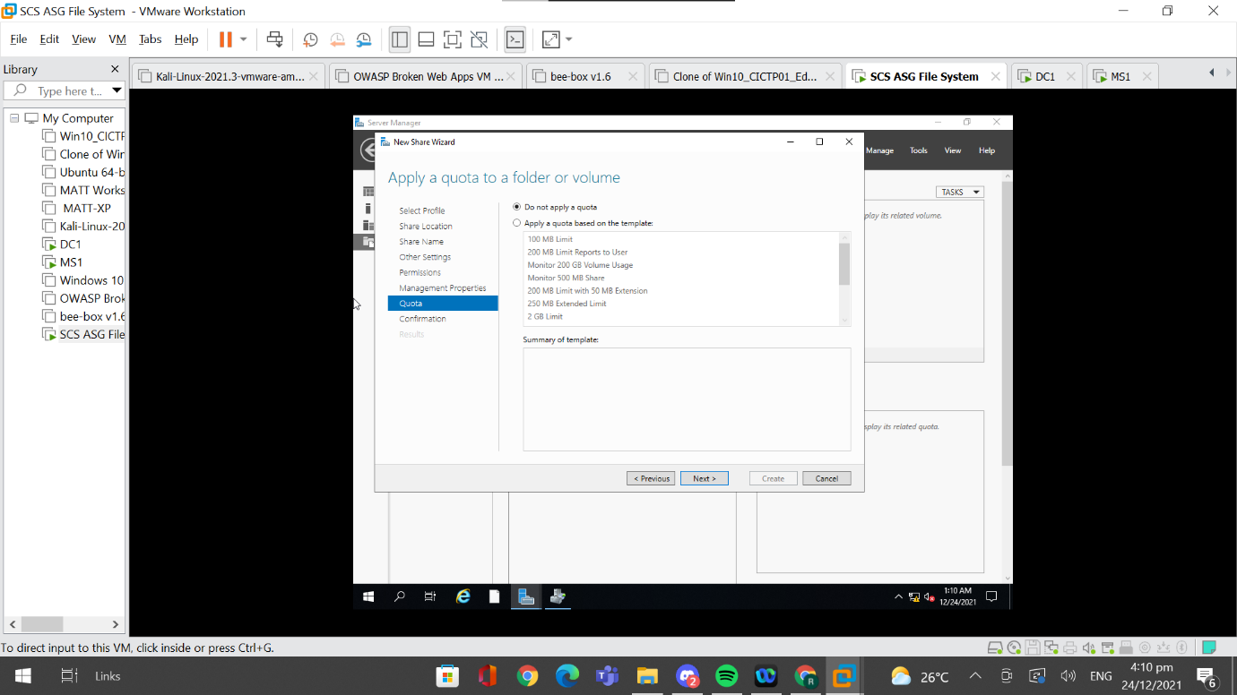

# 3. Testing of Shared Folder

I added a word document called “DF_ForensicTools_Edward” into the shared folder.

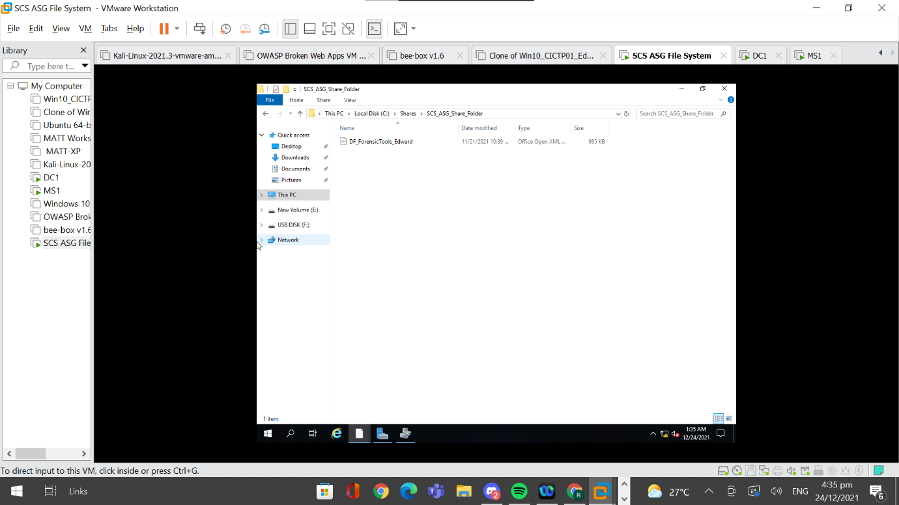

On the DC1 Virtual Machine I went to map a Network Drive so as to connect to the shared folder.

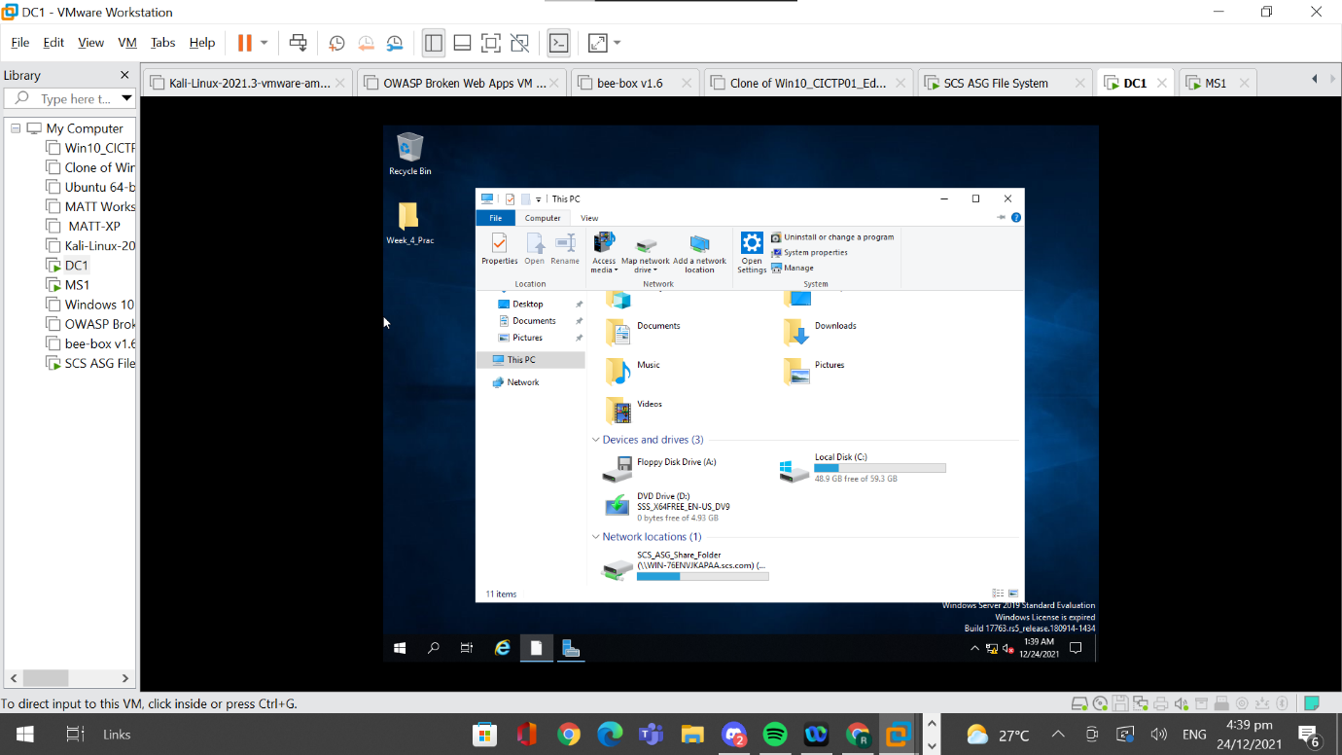

I then chose a Drive Letter that is available and for the folder path, I had to key in “\\WIN-76ENVJKAPAA.scs.com\SCS_ASG_Share_Folder”.

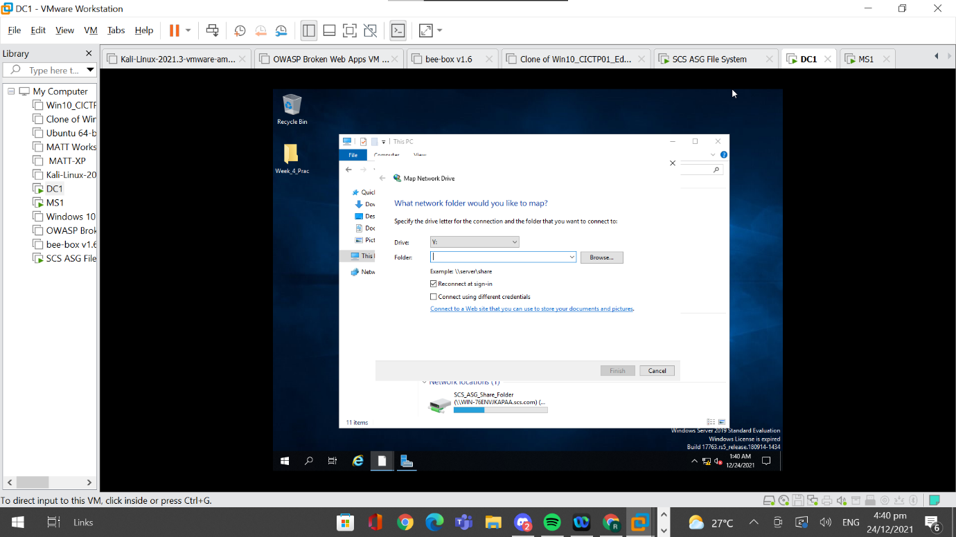

The mapped drive can be seen in Network Locations in “This PC” and if a successful connection can be made to the shared folder, it would show a green cable below the image of the disk.

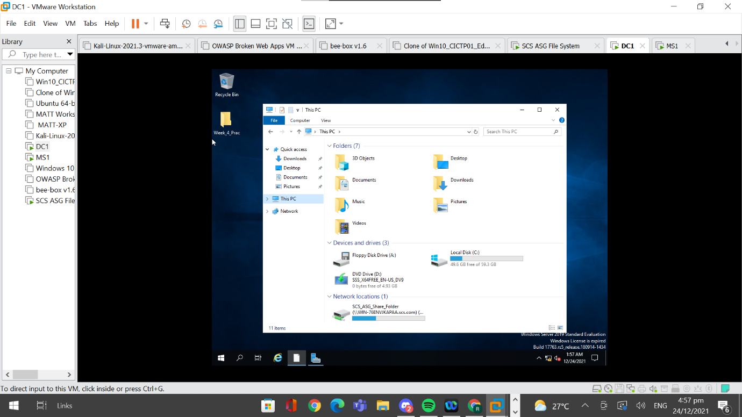

I managed to open the network drive and am able to see the word document, “DF_ForesenicTools_Edward” in the folder which suggests that the shared folder works.

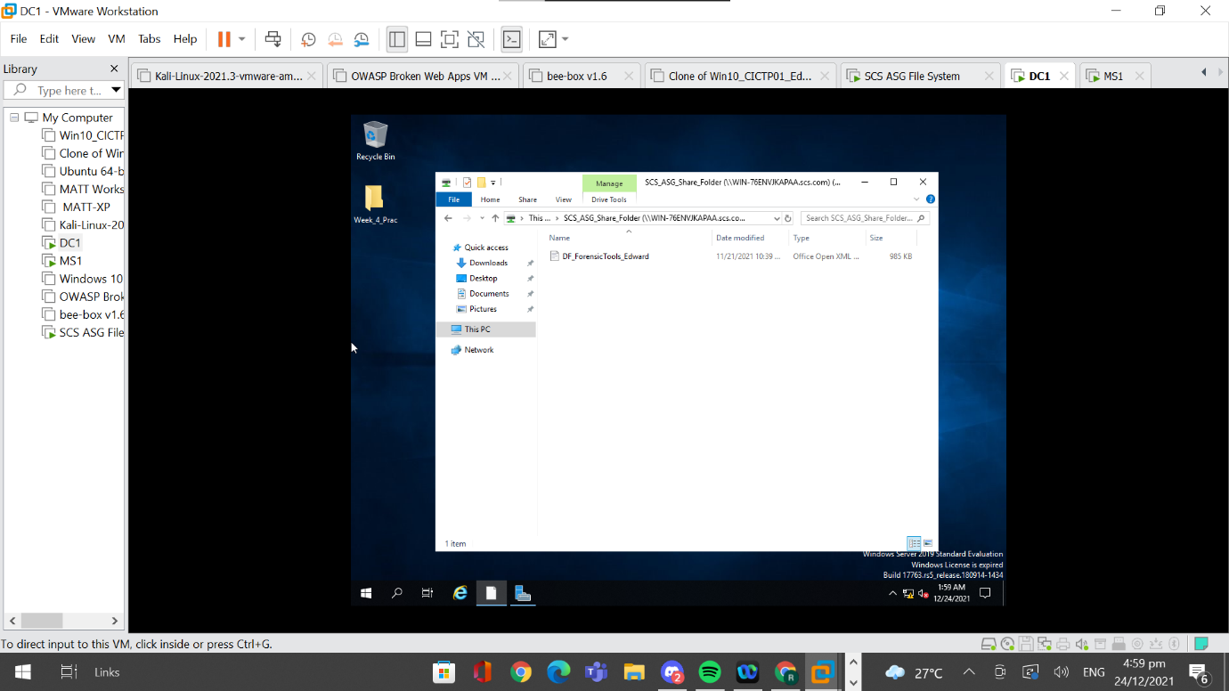

# 4. Hardening File Server

## 4.1 Configure Quota Limit

Setting a quota limit on the shared folder can be a means of hardening the file server because it prevents large files from being shared in the folder. Usually Adobe documents such as PowerPoint and Microsoft Word will only take a few MBs while applications have a size of a few hundred MBs. Thus, by having a quota limit, this reduces the chances of malicious applications being shared in a shared folder. This quota limit feature provided by the “File Server Resource Manager” also generates logs and reports which can be useful for the administrators.

### 4.1.1 Setting Up the Quota Limit

In order to set up the quota limit on the shared folder, I first went to “Tools” on server manager and then to “File Server Resource Manager”.

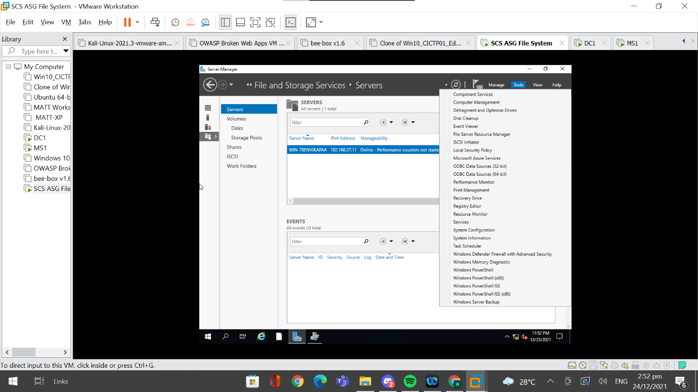

Next, I went to “Quota Management” and clicked on “Quota Templates”.

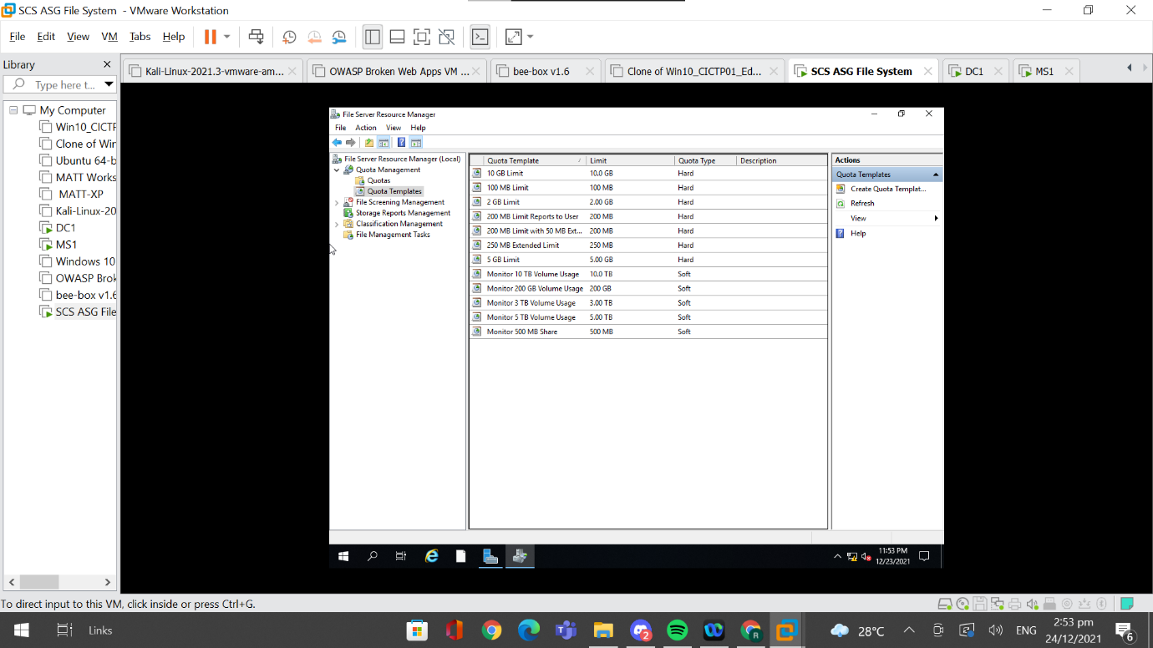

I then chose a suitable quota template, which in this case I selected 100MB limit. I selected it and ensured that the “Hard quota: Do not allow users to exceed limit” is ticked.

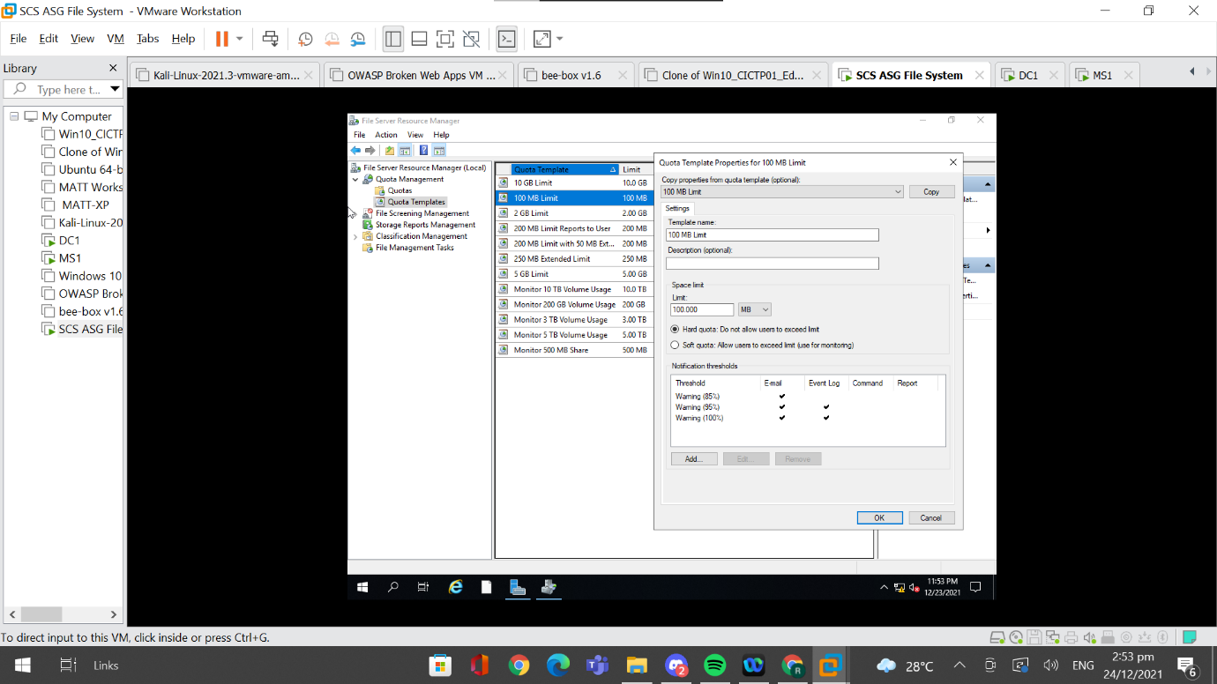

I clicked on “Add” so as to add a new threshold. After clicking on “Add”, I went to “Event log” and ticked “Send Warning to event logs”. This will audit any file transfer that is larger than the quota limit and will be saved to the event logs.

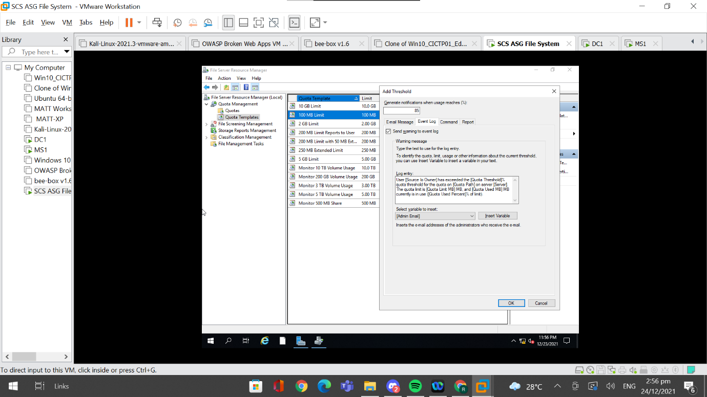

I then went to the “Report” subtab and ticked “Generate reports” and ticked the suitable options to generate a report on. In this case, I ticked “Duplicate Files” so as to identify which files are being duplicated so that they can be removed easier to save space, “Large Files” in order to identify large files that were transferred into the file server as large files could consist of malicious application, “Most recently accessed file” which allows me to identify which user accessed the file last, allowing me to have some sort of accounting to be reported. I also ticked “Quota Usage” which tracks the quota usage of the shared folder. I then changed the percentage to generate notifications to 75%, which means that once the storage of the shared folder reaches 75%, notifications will be sent to administrators.

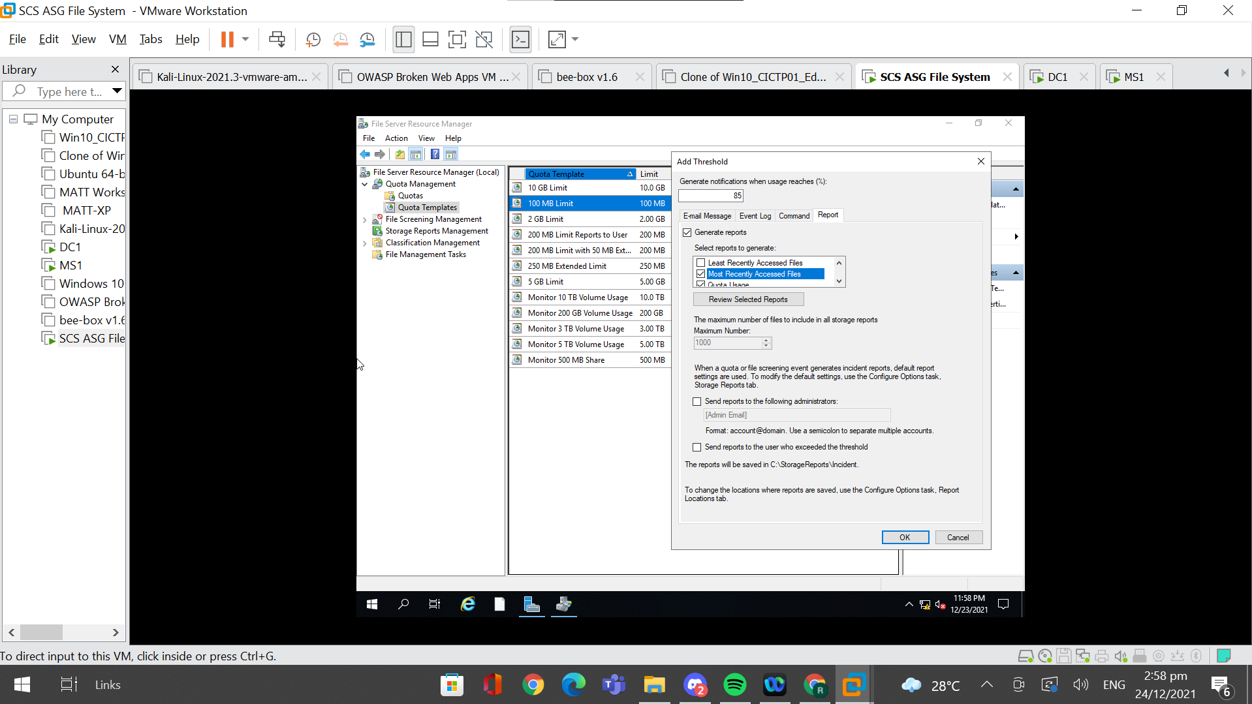

After editing the template, I then created a new quota by right-clicking “Quota” and clicking on “Create Quota…”.

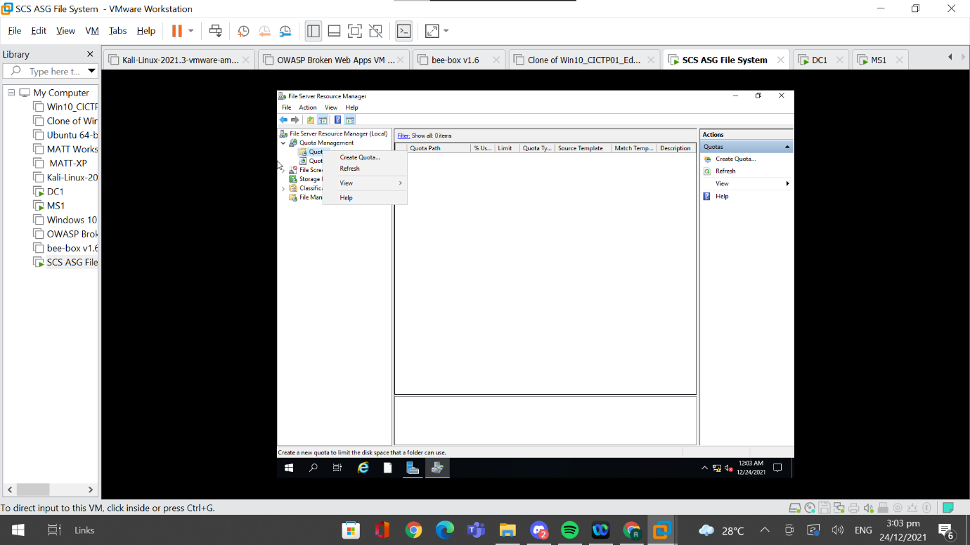

I then linked the created quota to the shared folder by specifying the path to be “C:\Shares\SCS_ASG_Share_Folder”. I also selected for the quota to use the recently created template by selecting to use the “100 MB Limit” template.

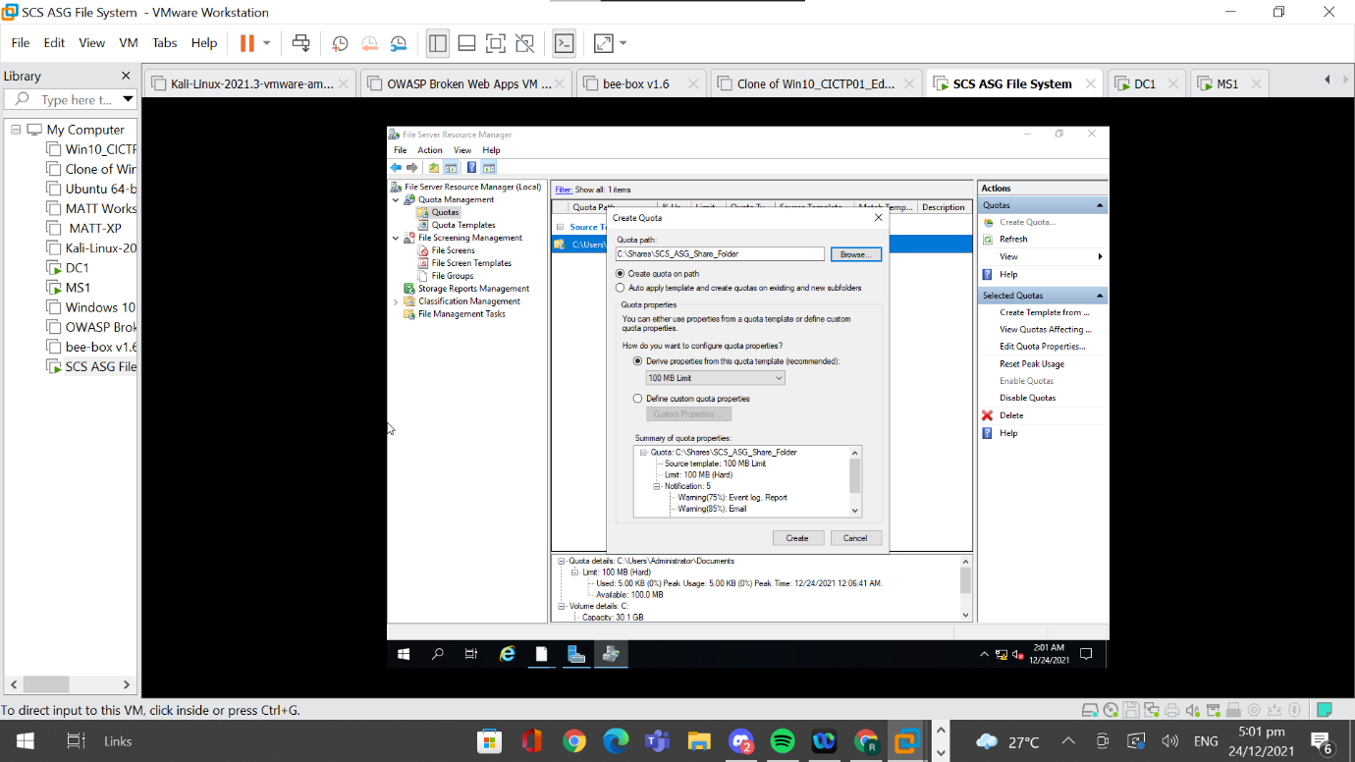

### 4.1.2 Testing Quota Limit

#### 4.1.2.1 File Larger Than 100 MB

The first test case I did was to try to move a file greater than 100 MB into the shared folder. When I tried to copy a file of 512 MB from my thumb drive to the shared folder, I was not able to copy it and had an error message stating that “There is not enough space on SCS_ASG_Share_Folder”.

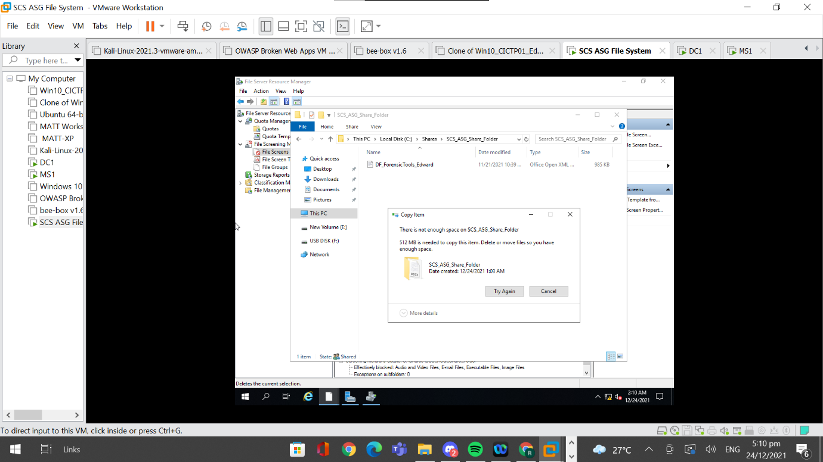

I then checked the event log to see if submitting a file that exceeds the quota limit will be logged. The details of the event log can be found in the image below.

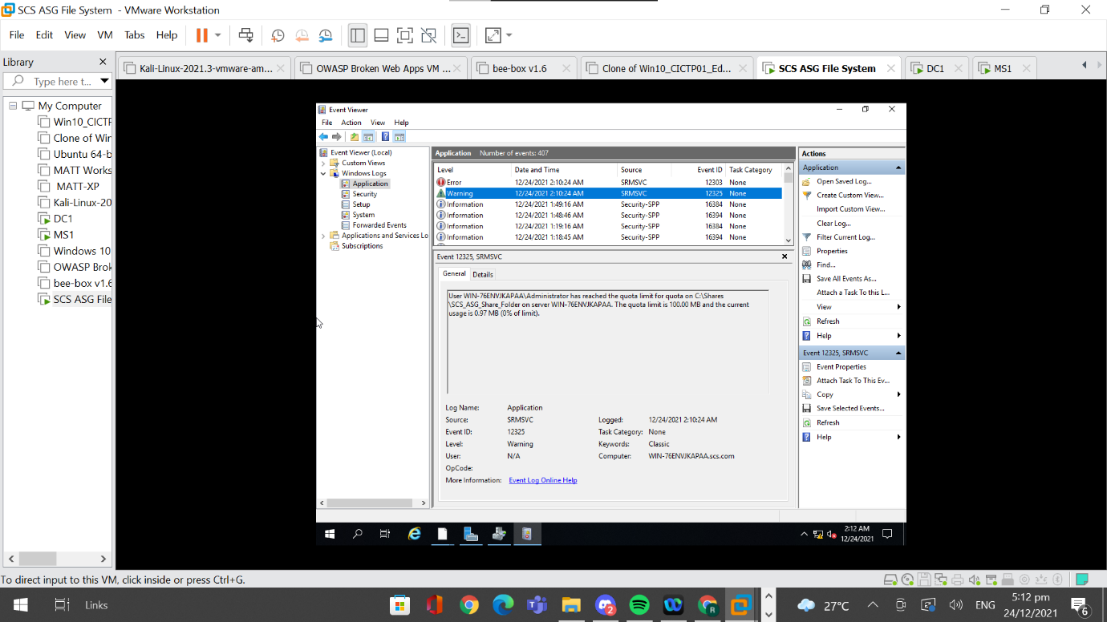

Reports were also generated and an example of the reports that were generated can be seen below.

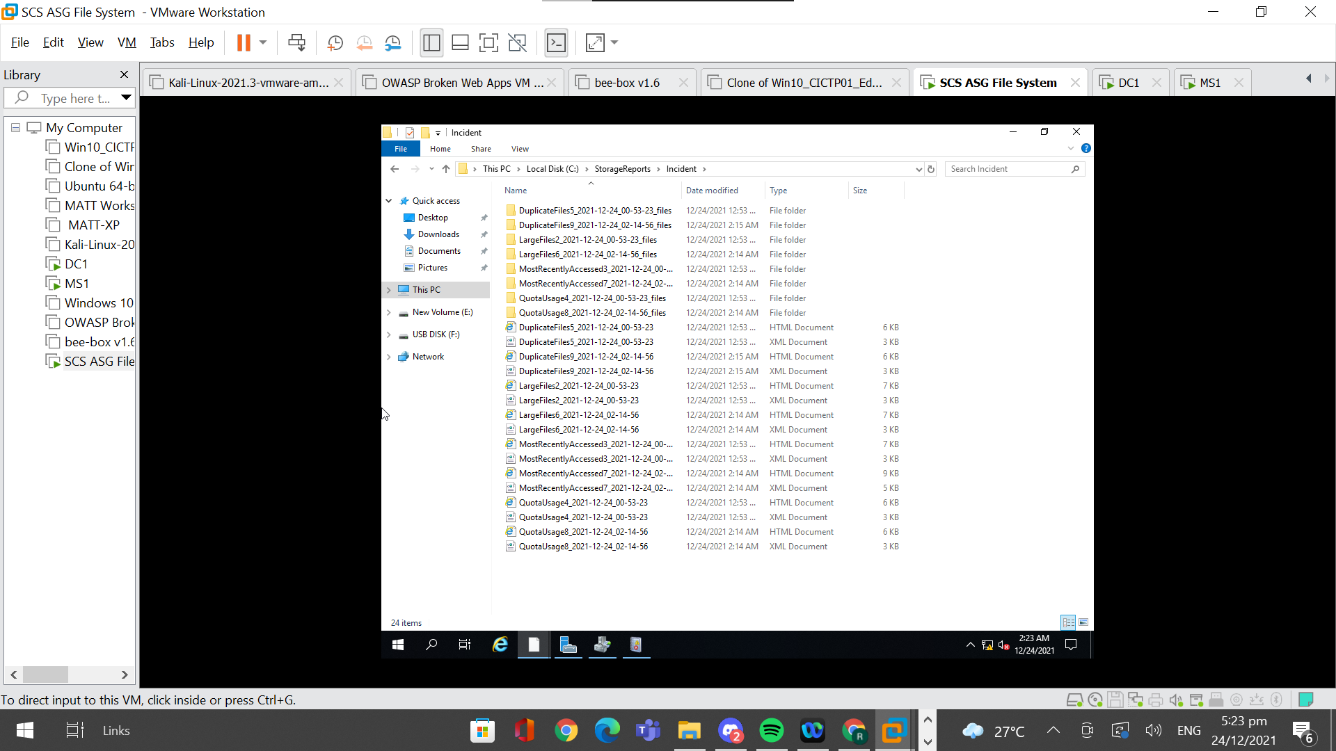

#### 4.1.2.2 Exceed Percentage Threshold

The second test case that I tried was to exceed the storage threshold of 75% to see if reports would be generated and if the event logs would take note of the storage exceeding the threshold limit. I added a file “EdwardNeo_JeremySng DF_RTF Report” that has a size of 74 MB into the shared folder and also copied the zipped folder present in the shared folder to increase the storage space used in the shared folder.

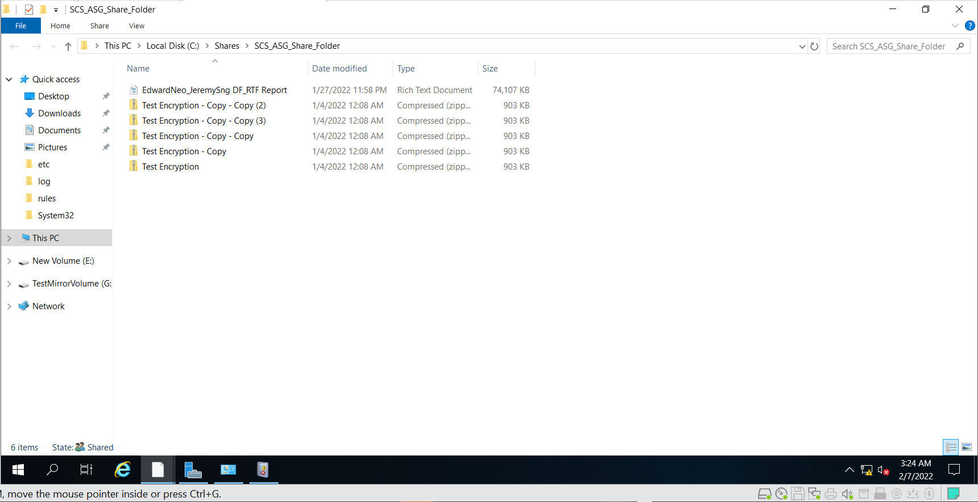

After ensuring that the space taken up in the shared folder is greater than 75%, I took a look at the “Event Viewer” and checked the event logs generated. I managed to identify a warning level event that shows that the file has exceeded the 75% quote threshold.

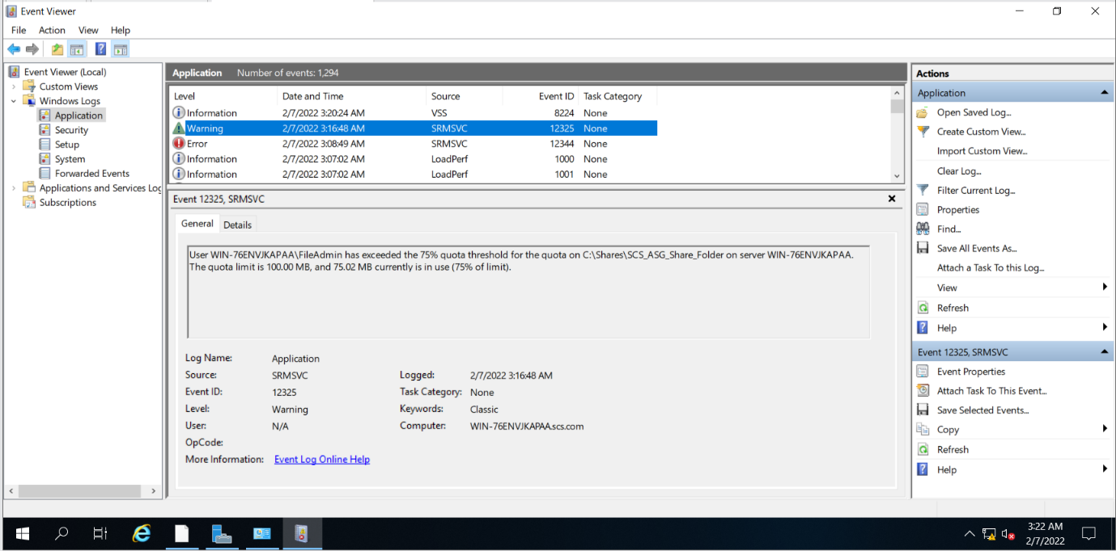

I also checked the folder where the generated reports are stored. In this folder, I could identify files that reflect the quota usage of the shared folder.

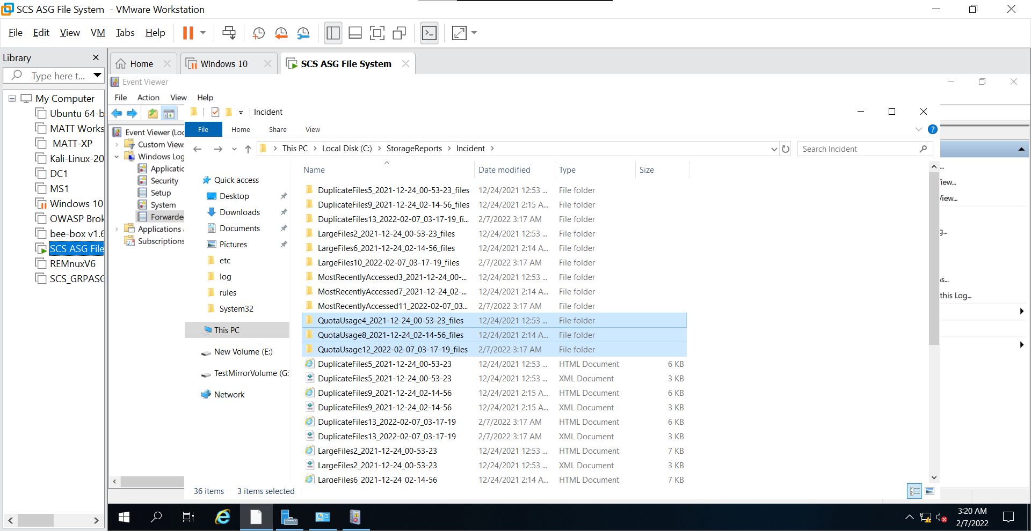

Thus, from the testing of the quota limit function, it can be seen that the quota limit was implemented correctly and is working as intended.

## 4.2 Configure File Screens

File screens are useful in securing the shared folder because the types of files that users can add into the shared folder are controlled and limited. We are able to have templates that can only allow files with certain extension types which can be useful for an organisation. This prevents malicious files that can be included in the shared folder which makes the shared folder more secure.

### 4.2.1 Setting Up File Screens

In order to set up file screens, I firstly went to “File Screening Management” and opened “File Groups”. This lists all of the file types a file can generally have.

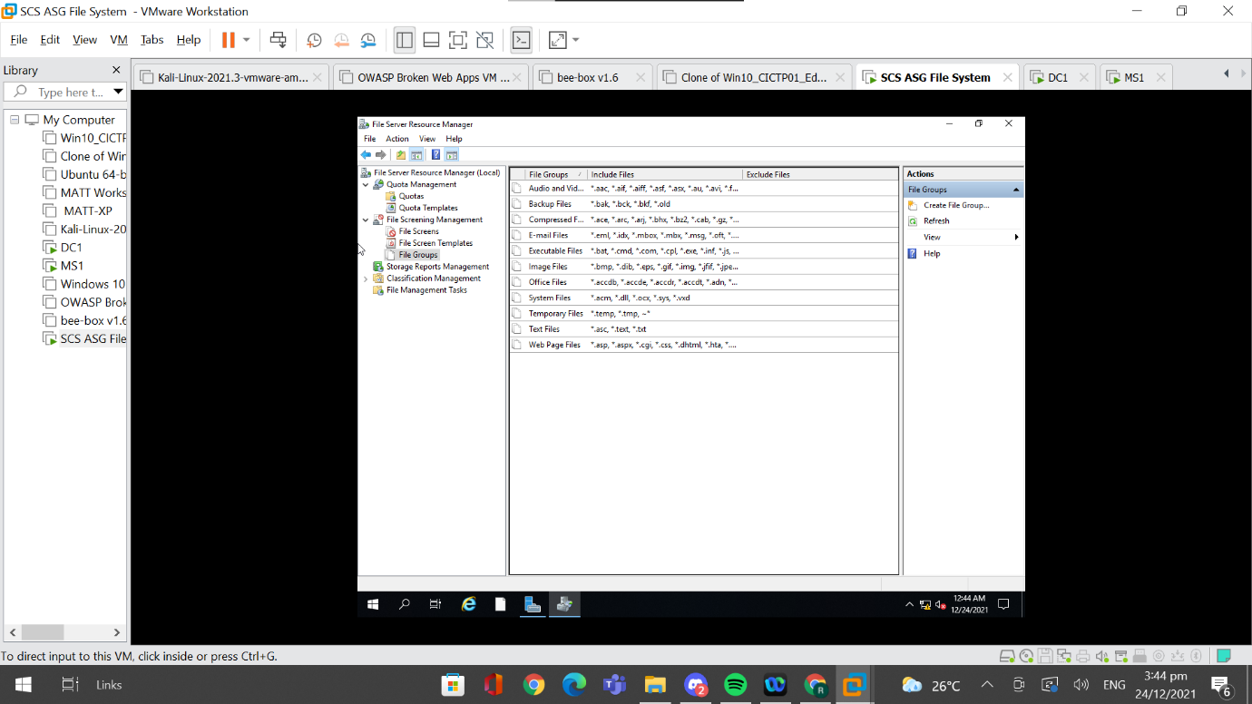

Next, I created a file screen template by going to “File Screen Template'' and clicking on “Create File Screen Template”. I then gave the template an appropriate name, “Testing of Block Files”. Since an organisation usually shares certain types of files, I blocked most types of file groups and only allowed certain types of files such as office files to be placed in the shared folder.

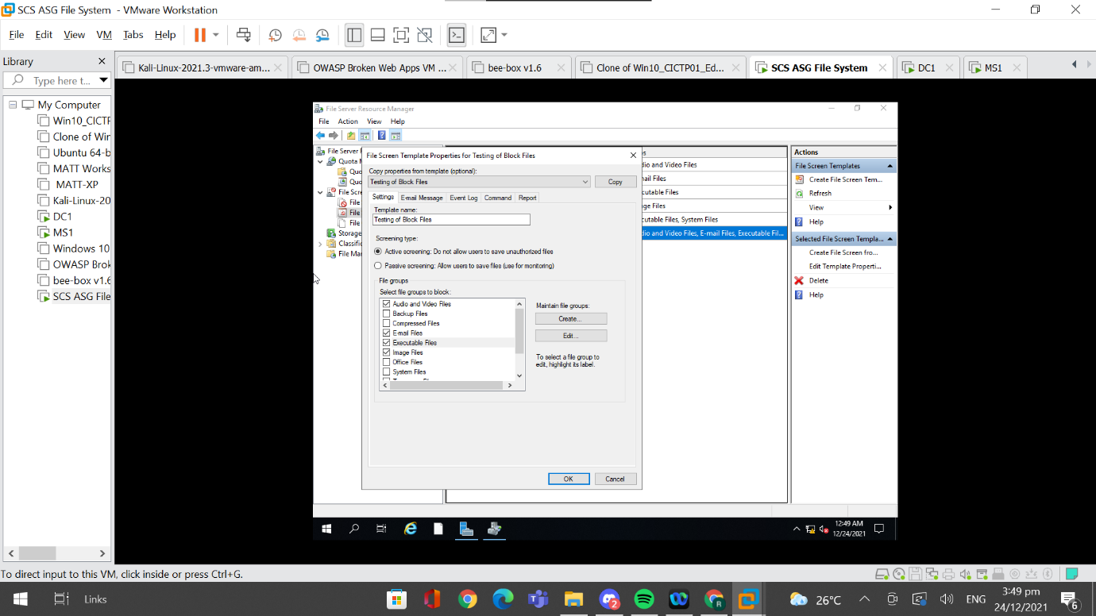

After creating the template, I went to “File Screens”, then clicked on “Create File Screen” and set the path to the shared folder, “C:\Shares\SCS_ASG_Share_Folder”. This is done so as to ensure that the file screen is being applied to the shared folder. Lastly, I have to select the created file screen template and click “Create”.

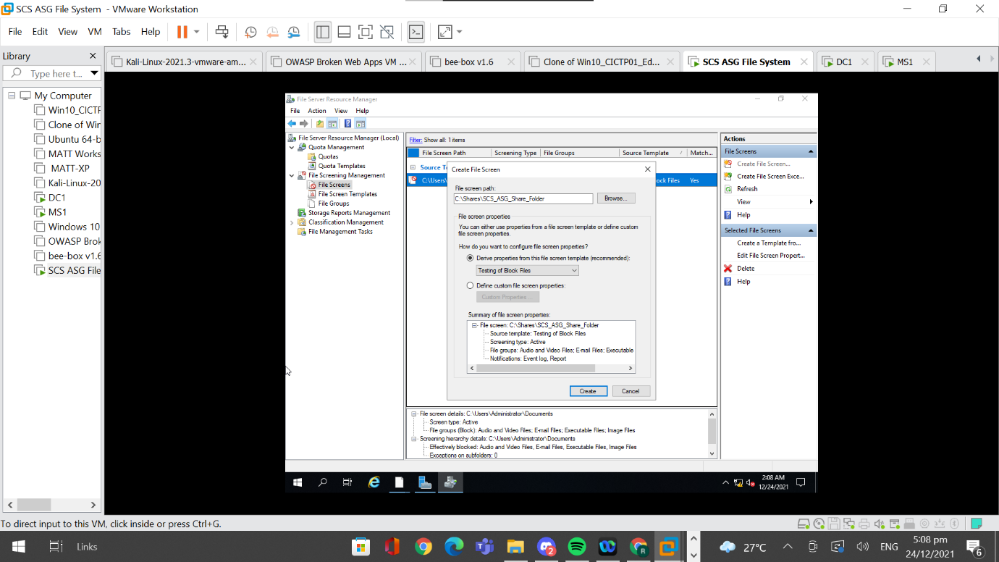

After configuring the file screen on the shared folder, I moved on to the testing of the file screen implementation.

### 4.2.1 Testing File Screens Implemented

The test case I did was to copy an image file into the shared folder. When I attempted to do so, I got an error message stating, “You need permission to perform this action”. Since image files are supposed to be blocked, this means that the file screen has been set up correctly.

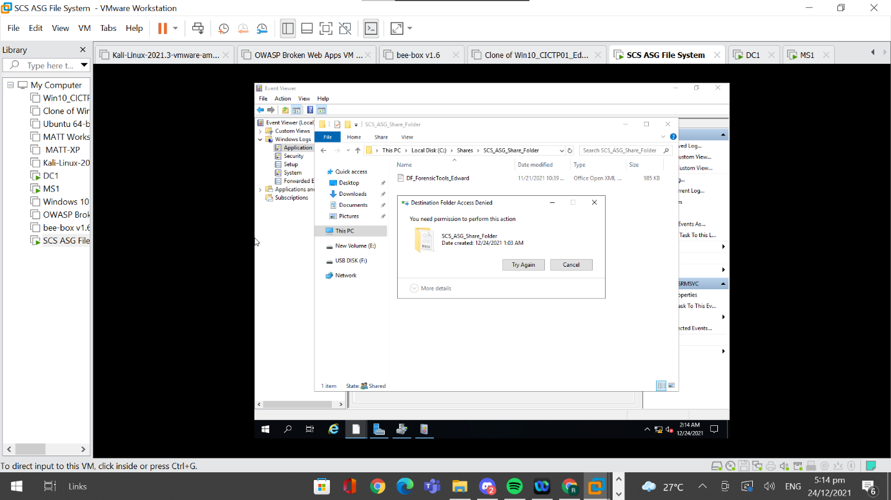

I also checked the event logs to see if this event will be logged. As seen in the above image, the event was logged when a blocked file group was copied over to the shared folder.

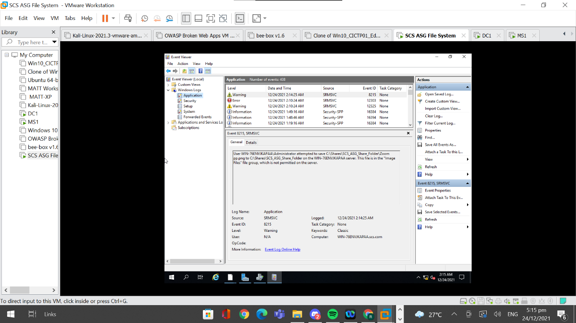

This means that the file screen was configured correctly and is working as intended.

## 4.3 AntiVirus

Having anti malware installed on the file server is extremely useful and important. Viruses and malwares can be installed accidentally from phishing emails or from web browsing, and having an antivirus software running constantly in the background can help identify and detect these suspicious and malicious software automatically. Having an antivirus software will allow for the early and quick detection of malicious software which will definitely help protect the file server. For the antivirus software, I used Windows AntiVirus which is inbuilt in the Windows operating system. The Windows AntiVirus not only detects malicious software quickly, but also contains and removes them from the server automatically.

### 4.3.1 Setting Up Windows AntiVirus

Windows AntiVirus is already activated on default and there are a few settings that I need to ensure are on. The first setting is “Real-time protection”. This needs to be on at all times because it monitors and checks the files on the system. It prevents malware from installing or running on the device and is extremely important for it to be on. The second setting is “Cloud-delivered protection” which protects data in the cloud. This setting works best when the third setting “Automatic Sample Submission” is on. The third setting sends files to Microsoft to help identify potential threats. This means that both the second and third settings can be used to block the download of suspicious files online and can also be used to determine whether the file is safe or malicious within a few seconds.

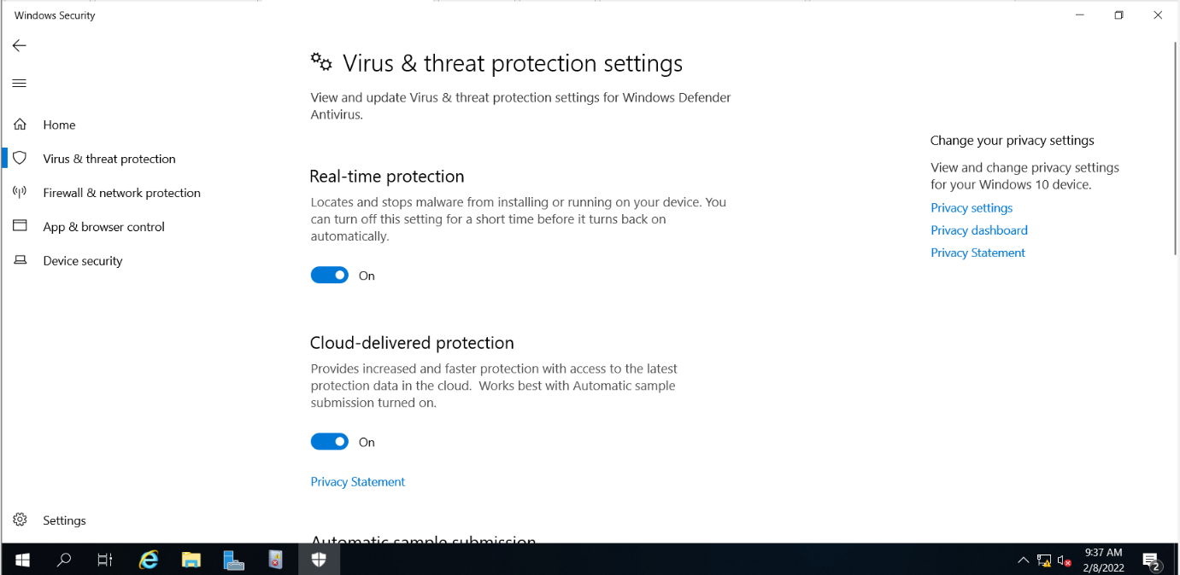

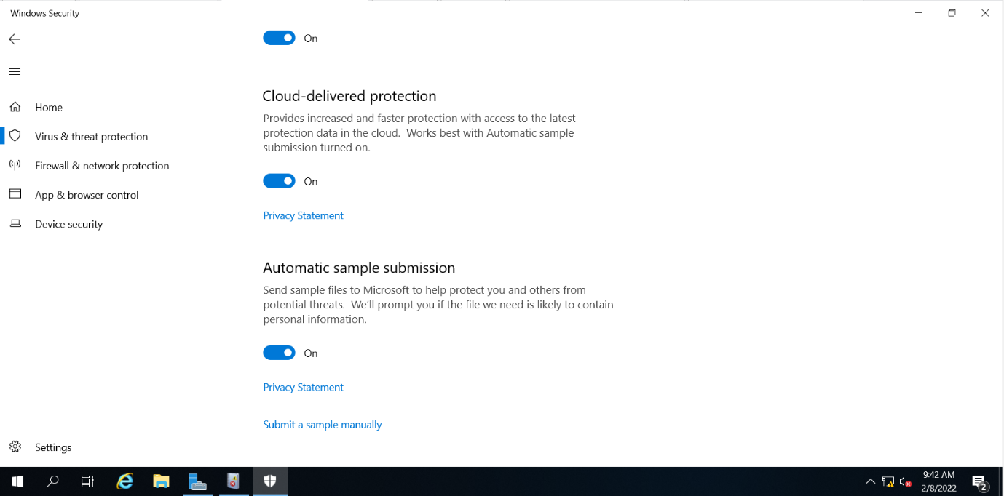

### 4.3.2 Testing Windows AntiVirus

I will be using a test file provided by EICAR. It is not an actual virus but most software reacts to it as a virus. It contains 68 characters, X5O!P%@AP[4\PZX54(P^)7CC)7}$EICAR-STANDARD-ANTIVIRUS-TEST-FILE!$H+H*. Any antivirus software that supports this test file will be flagged by the antivirus. As seen in the screenshot below, Windows AntiVirus managed to successfully identify this malicious file and removed the file immediately.

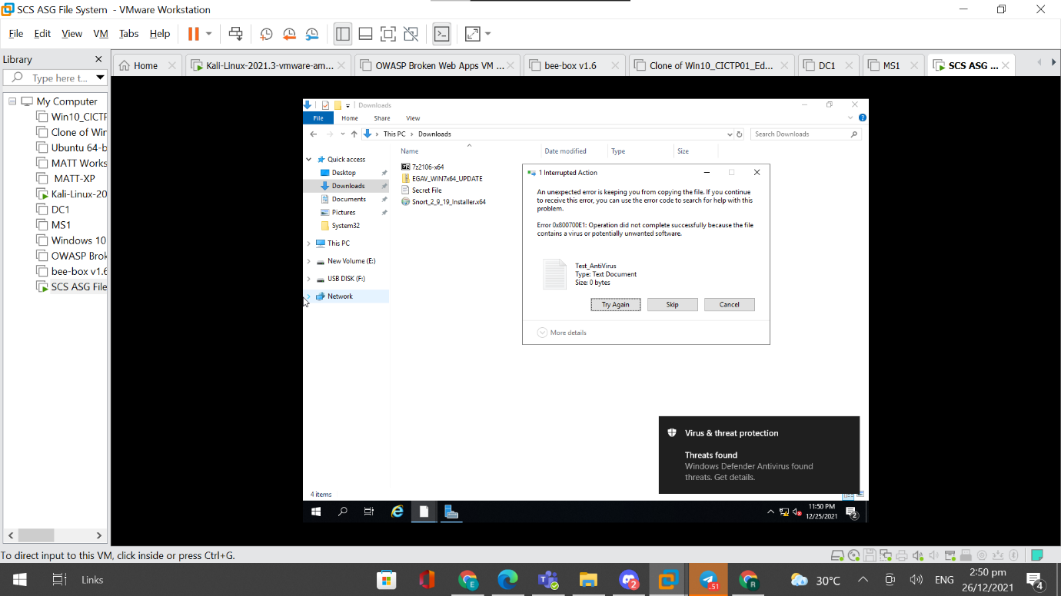

## 4.4 Host Firewall

Having a host-based firewall is crucial in protecting the file server. The firewall is used to control which traffic is able to communicate with the file server. It also helps detect and stop viruses, malware and other malicious scripts from accessing the file server. It allows administrators complete control in deciding which apps and features should be allowed for communication. For the host-based firewall, I used Windows inbuilt firewall software.

### 4.4.1 Setting Up Windows Firewall

I first ensured that the Windows Firewall is on and that the firewall for domain networks is connected. Since the file server is connected to a domain, only the firewall for domain networks needs to be on.

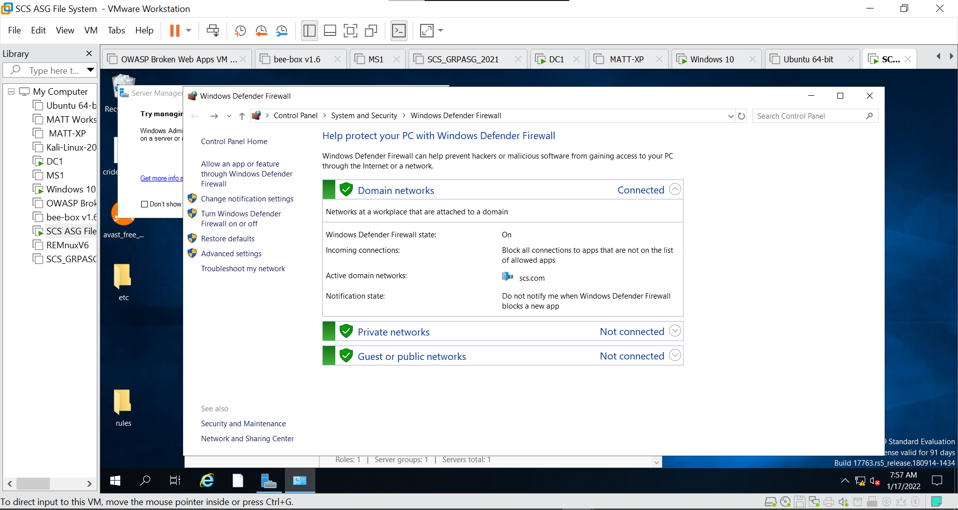

These are the apps and features that allow communication through Windows Defender Firewall. I felt that these are the most important and relevant features. There are features that are not as relevant such as “Desktop App Web Viewer” that were removed and there is no need for usage of the network since the users are connected to the same domain. Emails are also not needed since this is solely a file server. Thus, the only apps and features that were allowed include “File Server Remote Management”, “Windows Backup”, “Windows Security”, “Work or school account” or “Your account”. “File Server Remote Management” is needed to host the file server and is required for access to the share folder from other computers. “Windows Backup” is needed because the shared folder will be backed up by Windows Server Backup. “Windows Security” is enabled because security is still needed on a file server and should not be neglected. “Work or school account” and “Your account” are also enabled because anyone in the domain should be able to access the shared folder.

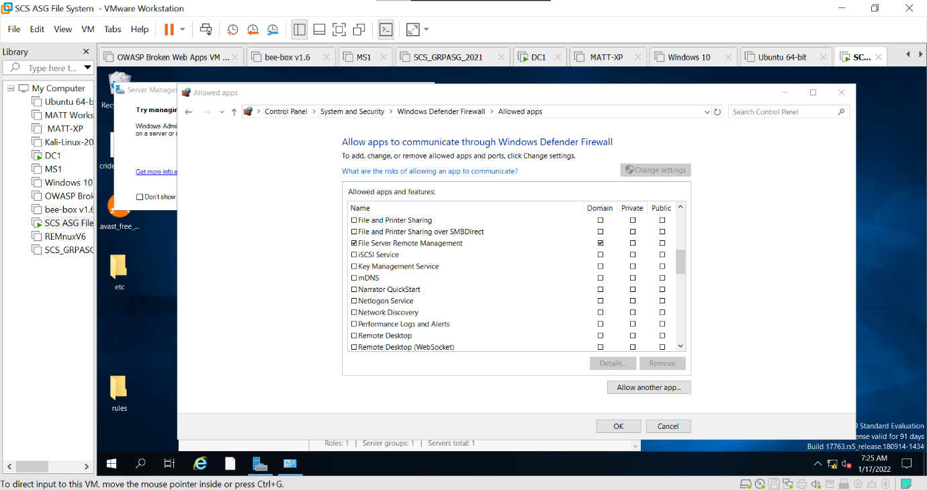

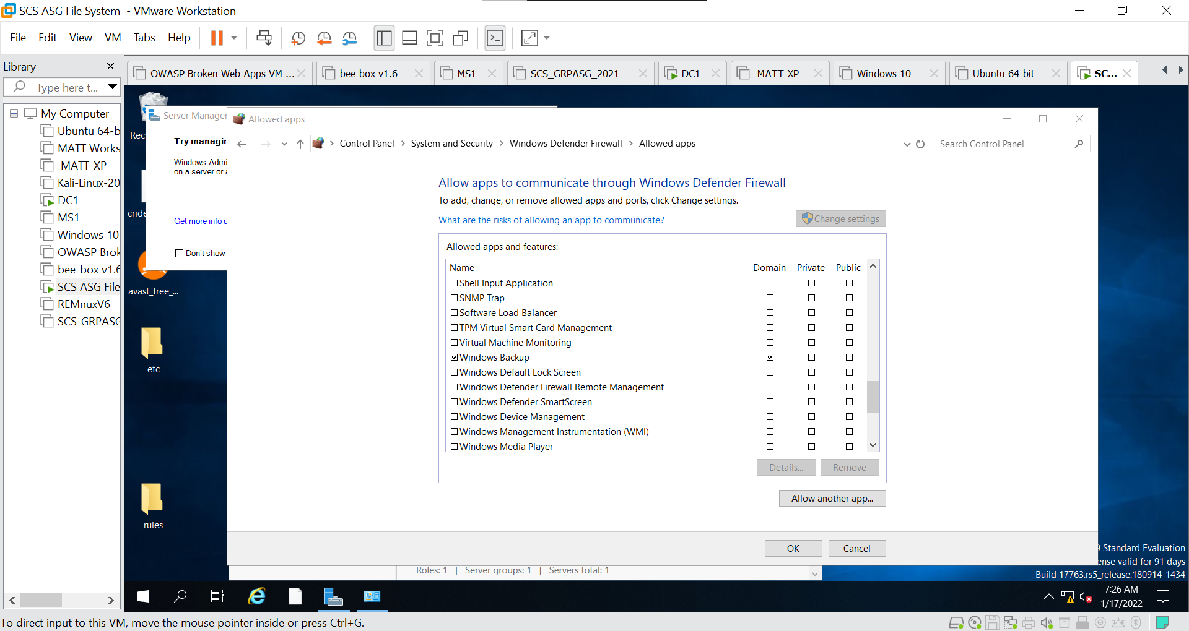

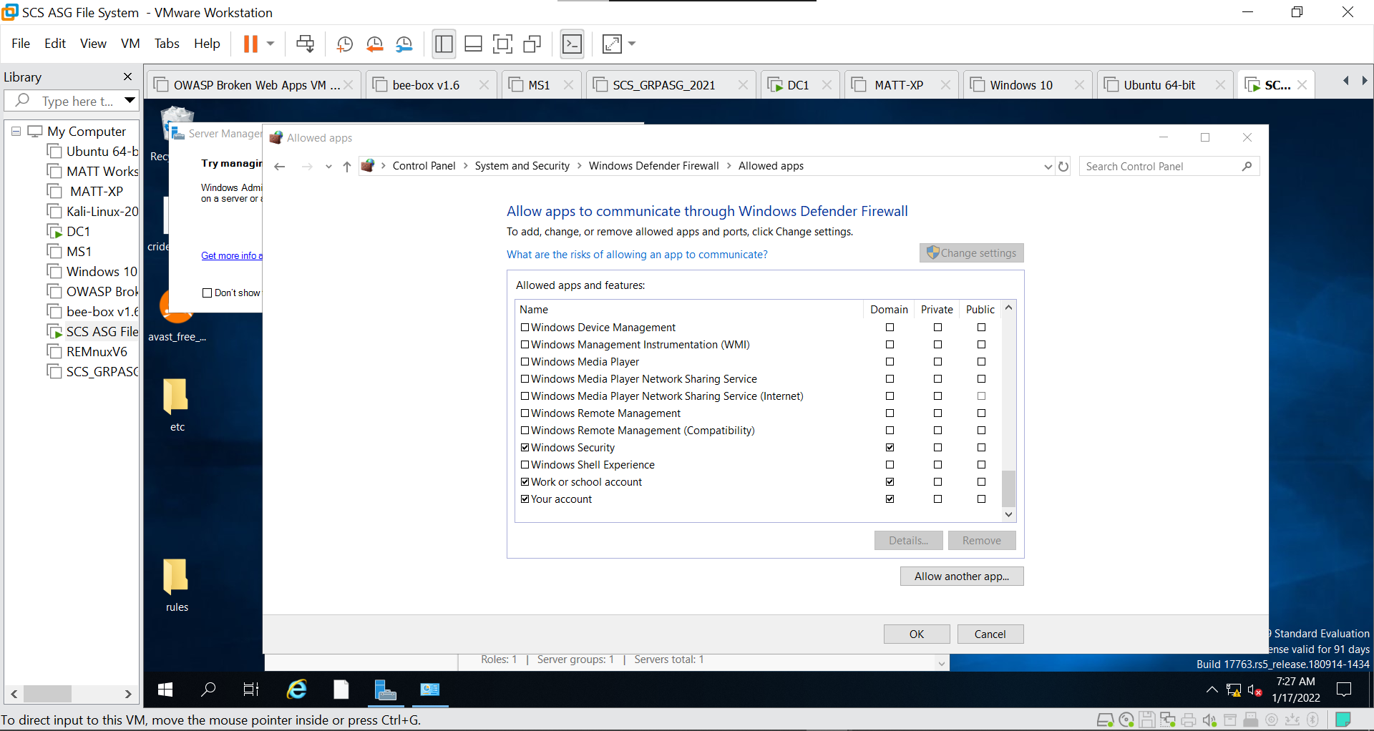

Then, I enabled logging so that it logs all rejected packets and successful connections. These logs are stored in the default directory, “%SYSTEMROOT%\system32\logfiles\firewall\pfirewall.log”.

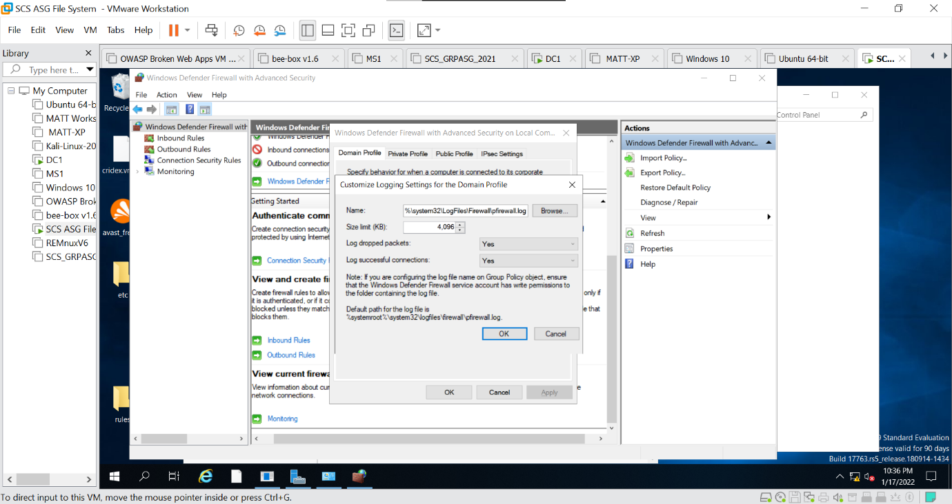

### 4.4.2 Testing Host Firewall

I first tested out the firewall by using an account connected to the domain to see if he can access the shared folder. I used the domain controller to see if it could connect to the shared folder

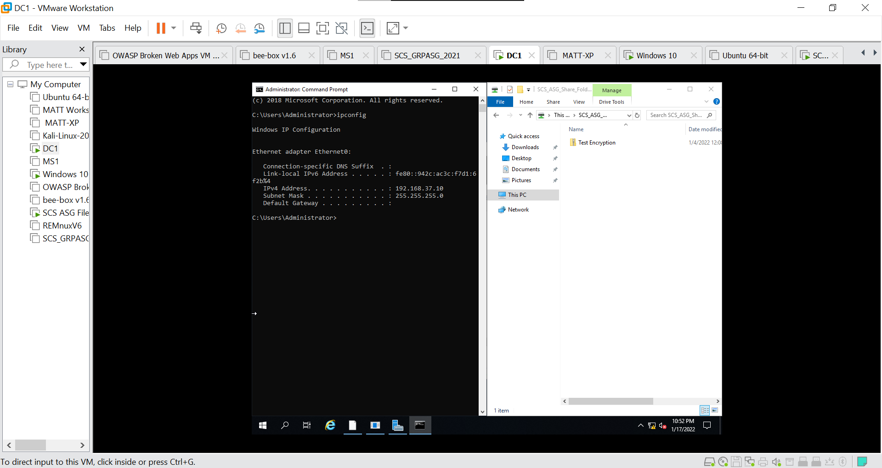

I then tested out using another Windows 10 user that does not belong to the same domain as the file server to see if he can access the shared folder. As we can see from the screenshot above, the user was not able to access the shared folder which means that the firewall filter works.

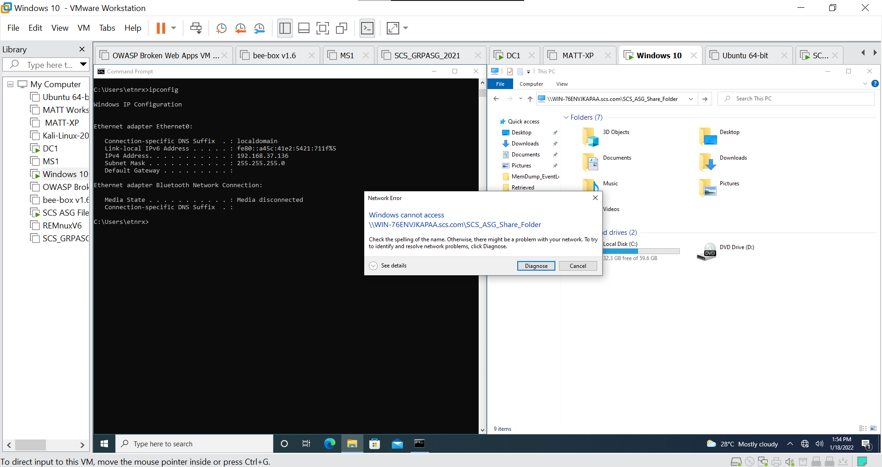

I can also see in the log file that the domain controller with an ip address of 192.168.37.10 was able to access the shared folder and bypass the firewall. However, when I tried a user outside the domain, it was not able to bypass the firewall. This user has an ip address of 192.168.37.136 and was dropped by the firewall.

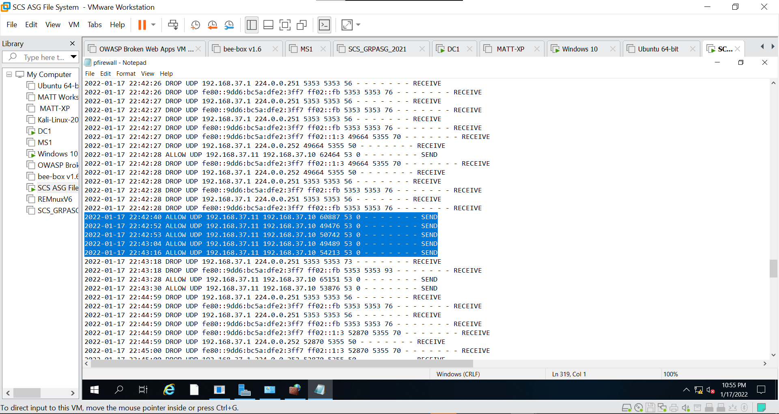

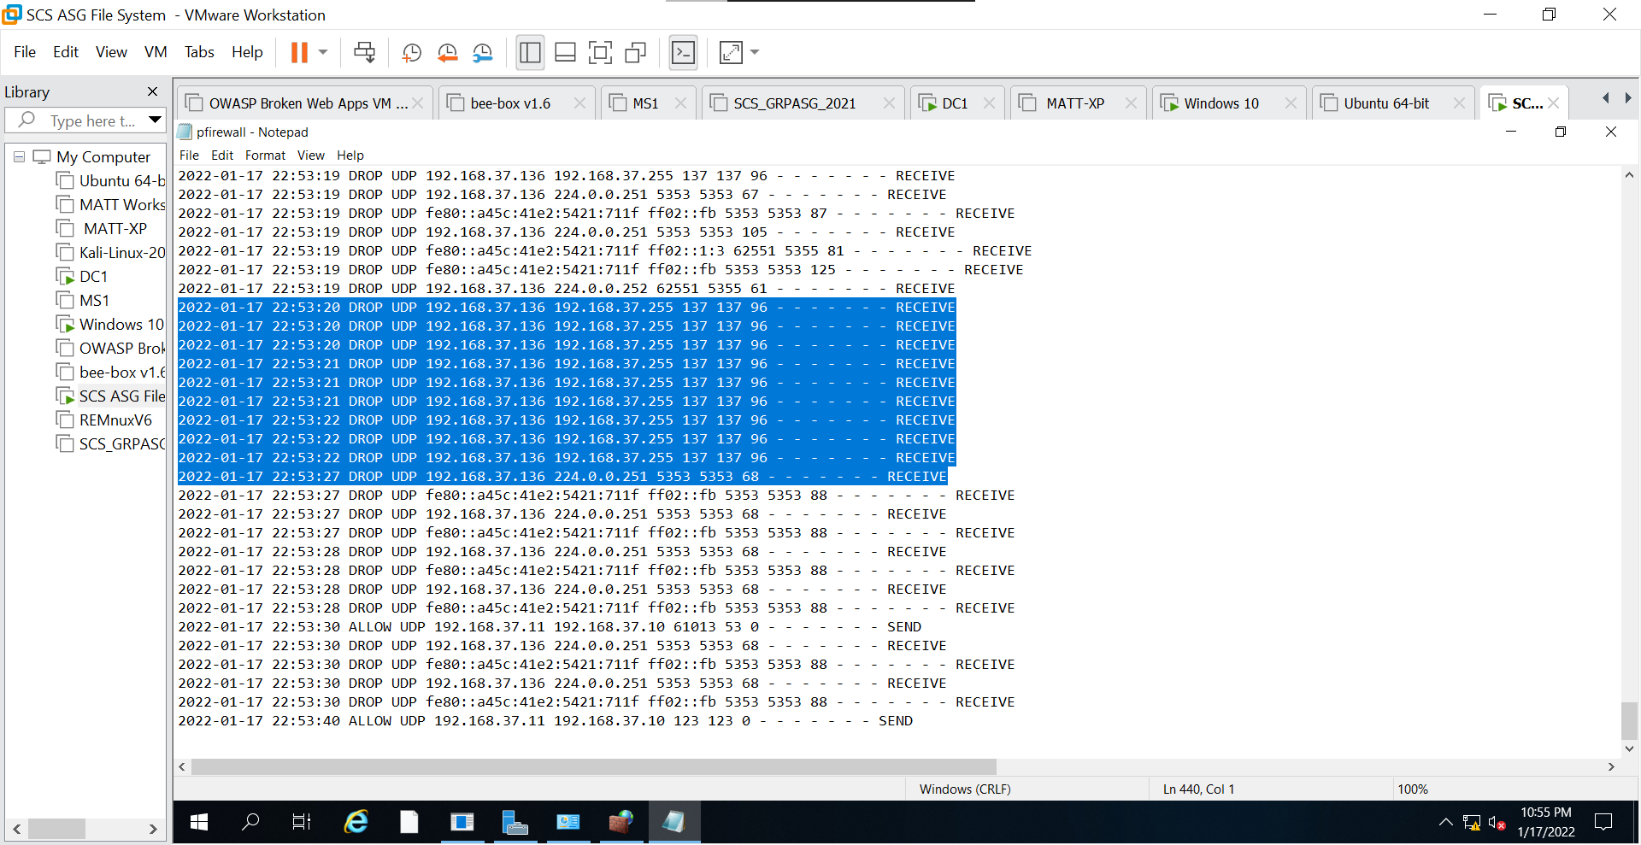

I also decided to use nmap to check the opened ports on the file server to see if the firewall is working as intended. There were only three ports opened and the rest of the ports were closed. These three ports are “135”, “139” and “445”. These ports are needed for the file server to function. Port 135 is required by the server for communication with the domain controller. Port 139 and 445 are required as it provides access to shared resources, which in this case would be the shared folder. SMB protocol requires these two ports and since the shared folder uses SMB protocol, these two ports should be opened.

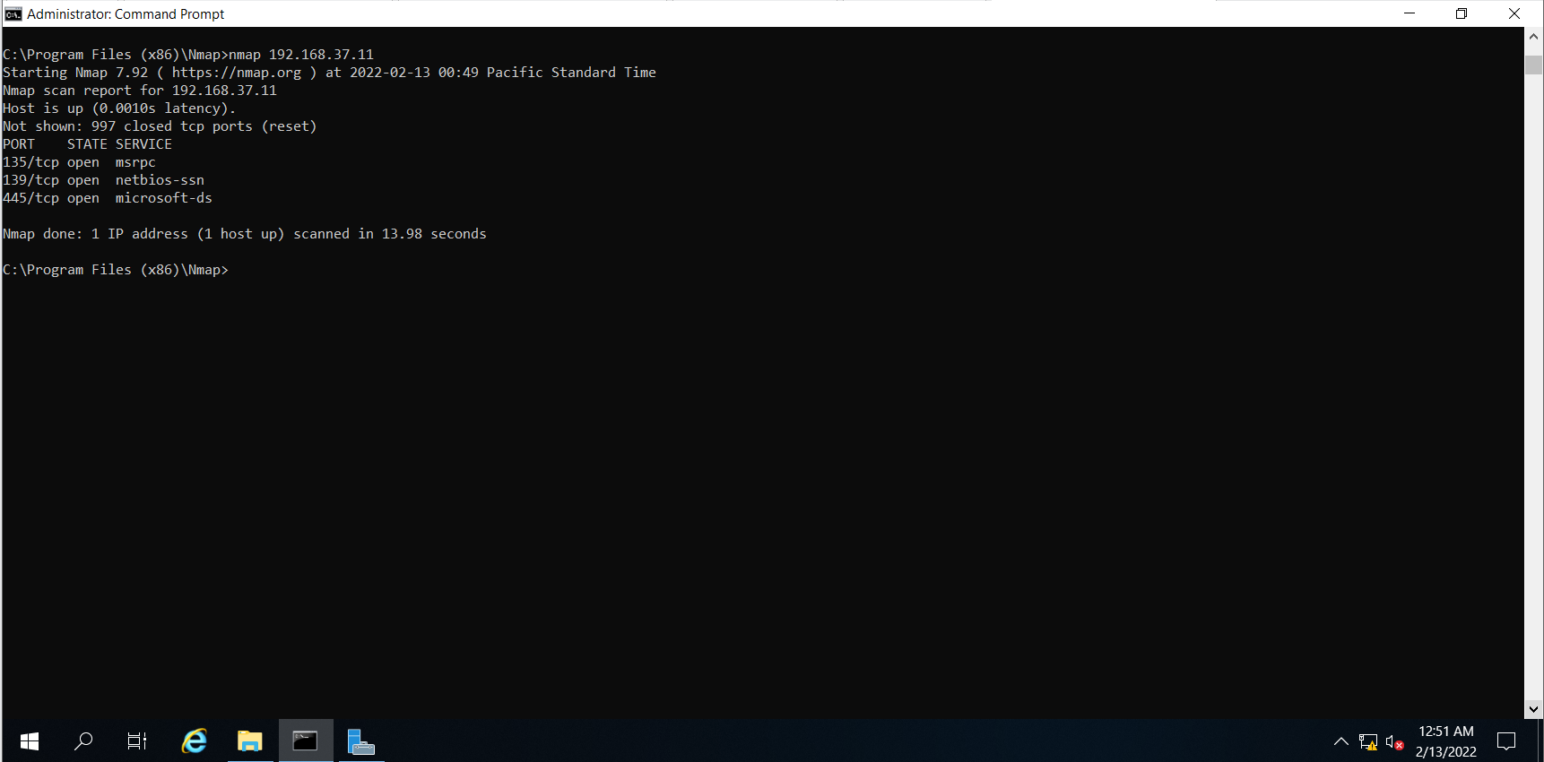

## 4.5 Host Intrusion Detection / Prevention System(IDS/IPS)

An IDS/IPS should definitely be set up in order to safeguard the file server. An IPS detects and prevents identified threats while an IDS only detects threats. It constantly monitors the network and looks out for malicious incidents and captures information about them. It reports any events to administrators and an IPS also takes preventive action automatically so as to prevent the malicious software from causing any damage to the network. The host-based IDS/IPS I will be using is Snort. Snort is an open source IDS/IPS tool that uses a series of rules to define malicious network activity.

### 4.5.1 Setting Up Snort

In order to use Snort, I first had to install Microsoft Visual C++ Redistributable Update 3 RC, npcap and Snort.

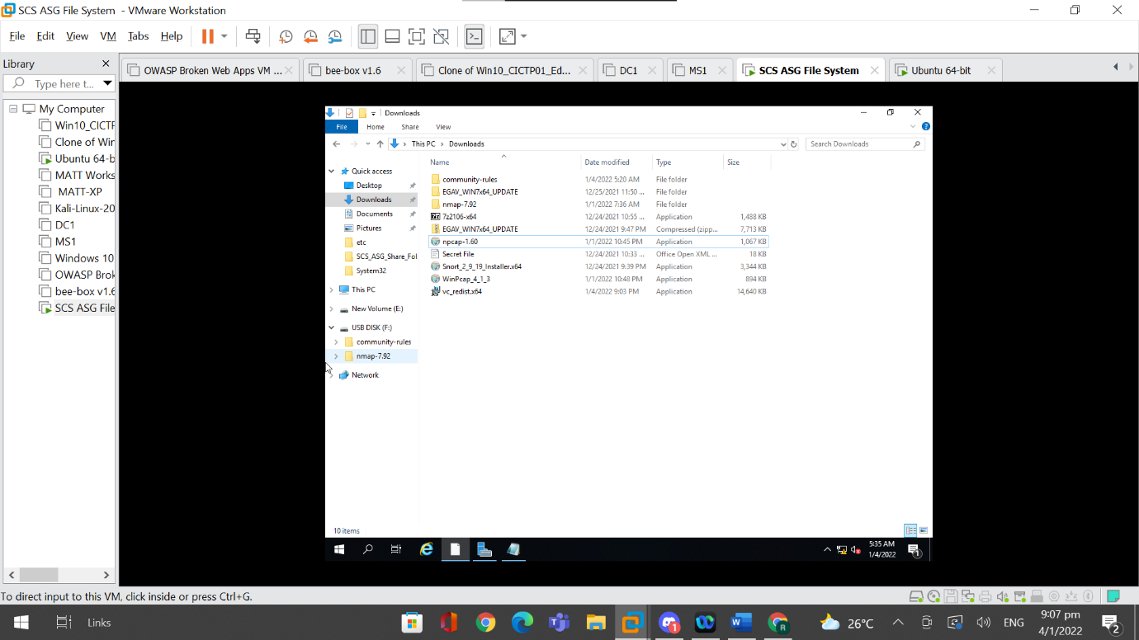

Then, I installed some custom-made rules to use for Snort. Since the snort version downloaded was 2.9, a zipped file of the snort rules used in Snort v2.9 was downloaded.

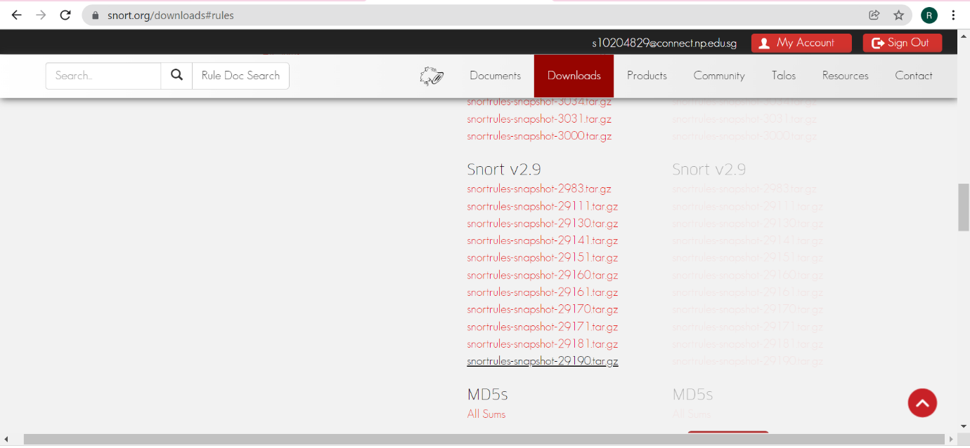

These are the contents of the downloaded snort rules.

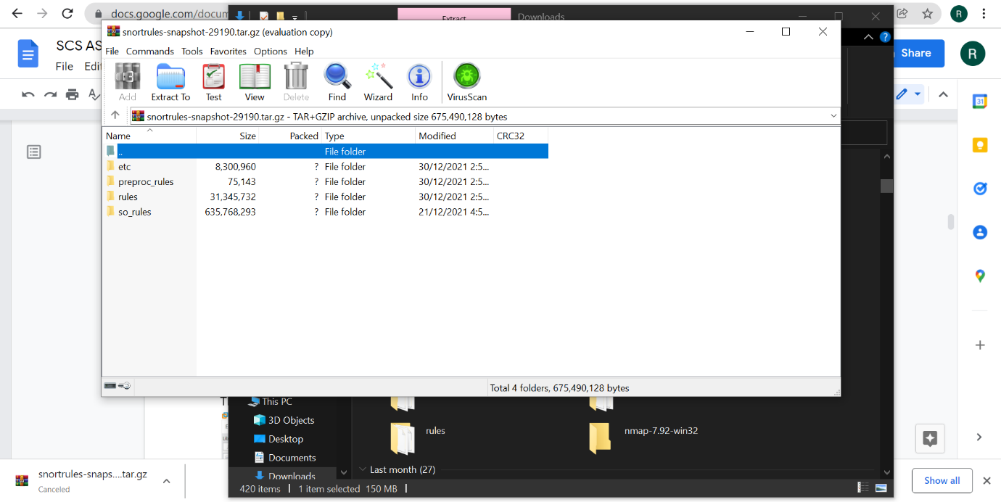

After downloading the rules, I had to copy all the Rules files from the Rules folder into the rules folder into my own Snort directory, which in this case would be C:\Snort\Rules. I also had to add the downloaded prepoc_rules folder and so_rules folder into my own Snort directory.

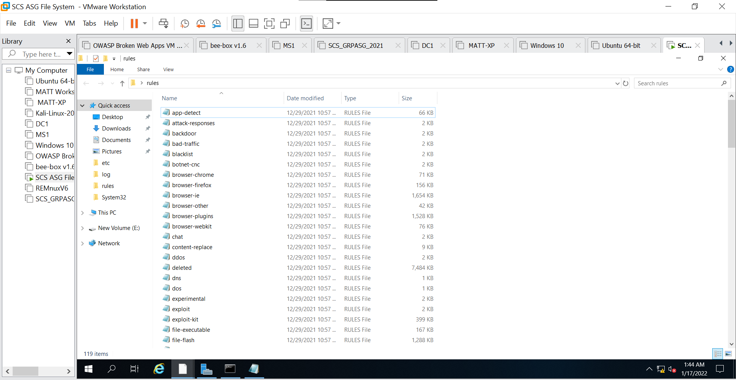

Next, I had to edit the config file of Snort which can be done by going to C:\Snort\etc and opening snort.conf with a notepad.

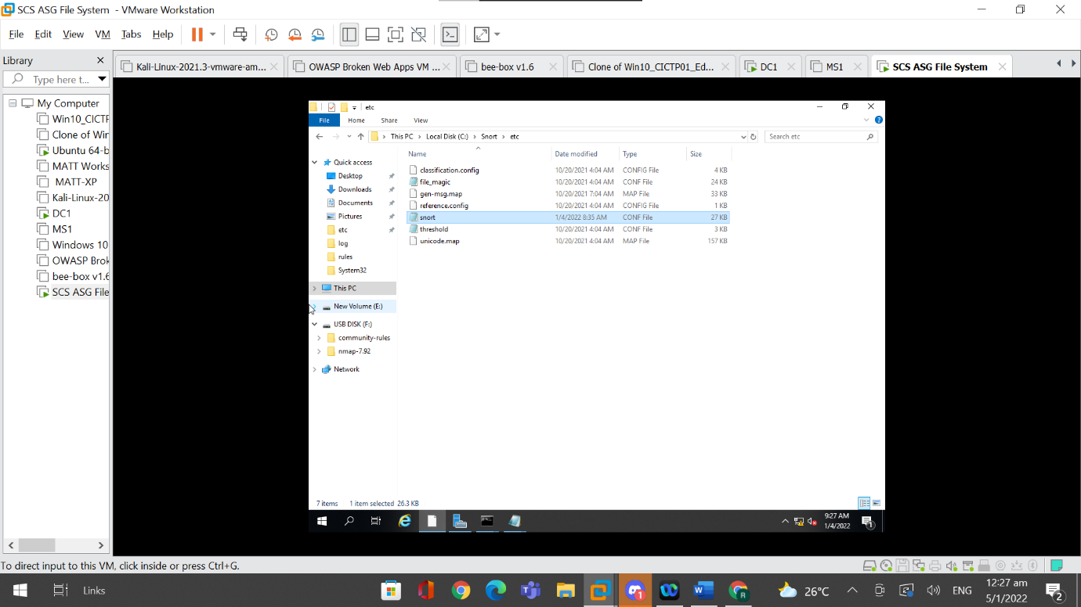

There are several changes that need to be made in the snort.conf file in order for Snort to work. Firstly, I had to change the “Setup the network addresses you are protecting” to ipvar HOME_NET {ip address of file server}. Then I had to change the “Set up the external network addresses” to ipvar EXTERNAL_NET !$HOME_NET, which means that Snort will consider all ip addresses other than the ip address of the file server to be from external sources.

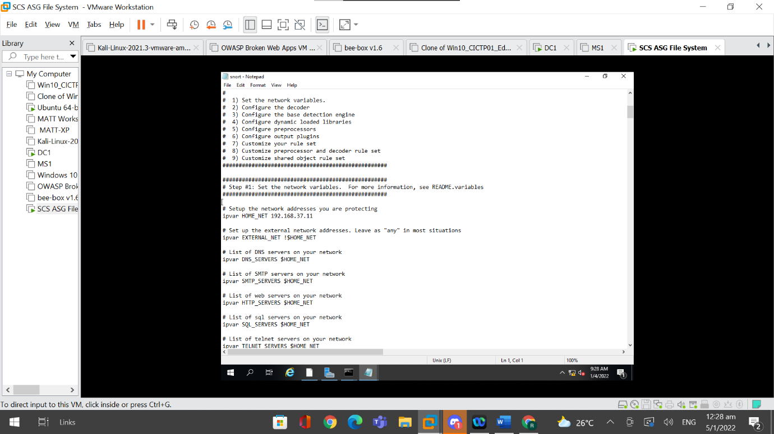

Next, I had to adjust the paths specified in the rules folder. In this case, RULE_PATH would be C:\Snort\Rules, PREPOC_RULE_PATH would be C:\Snort\prepoc_rules, and SO_RULE_PATH would be set to C:\Snort\so_rules

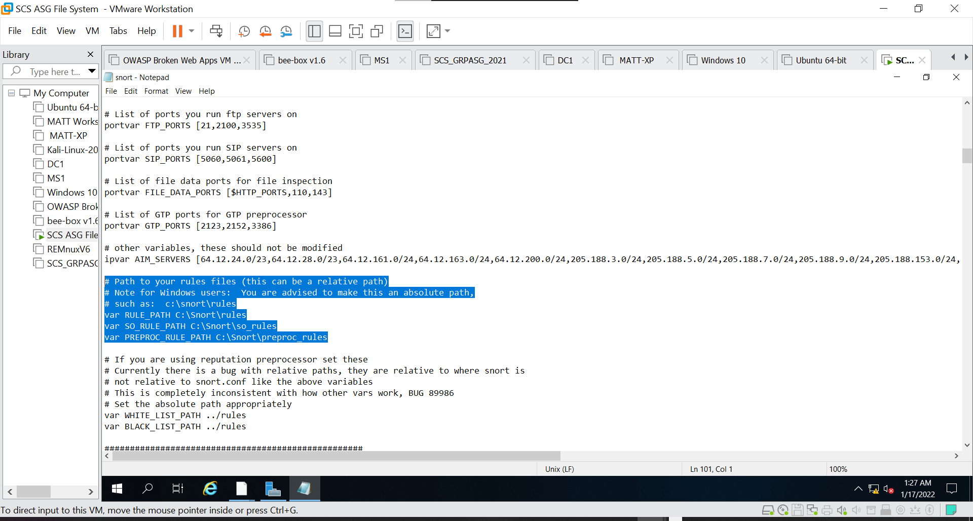

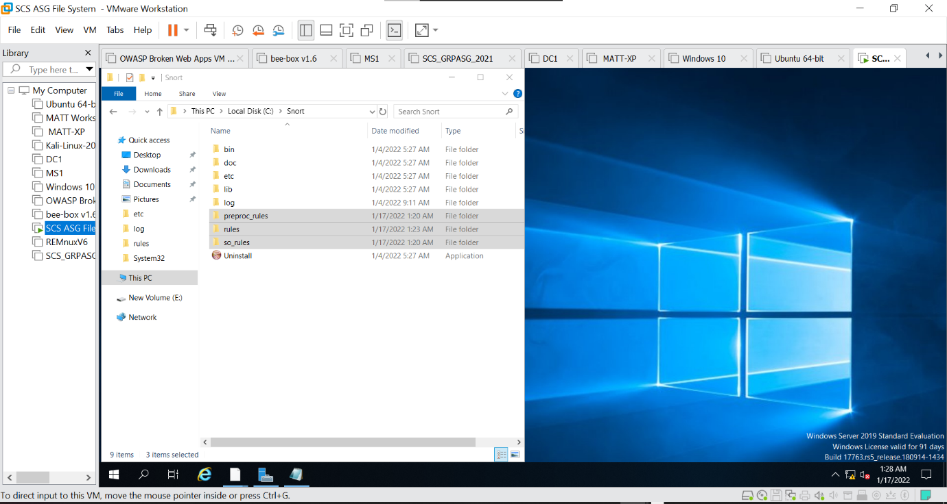

Afterwards, I had to specify the log directory, which is C:\Snort\Log as this will be used by Snort to write logs to.

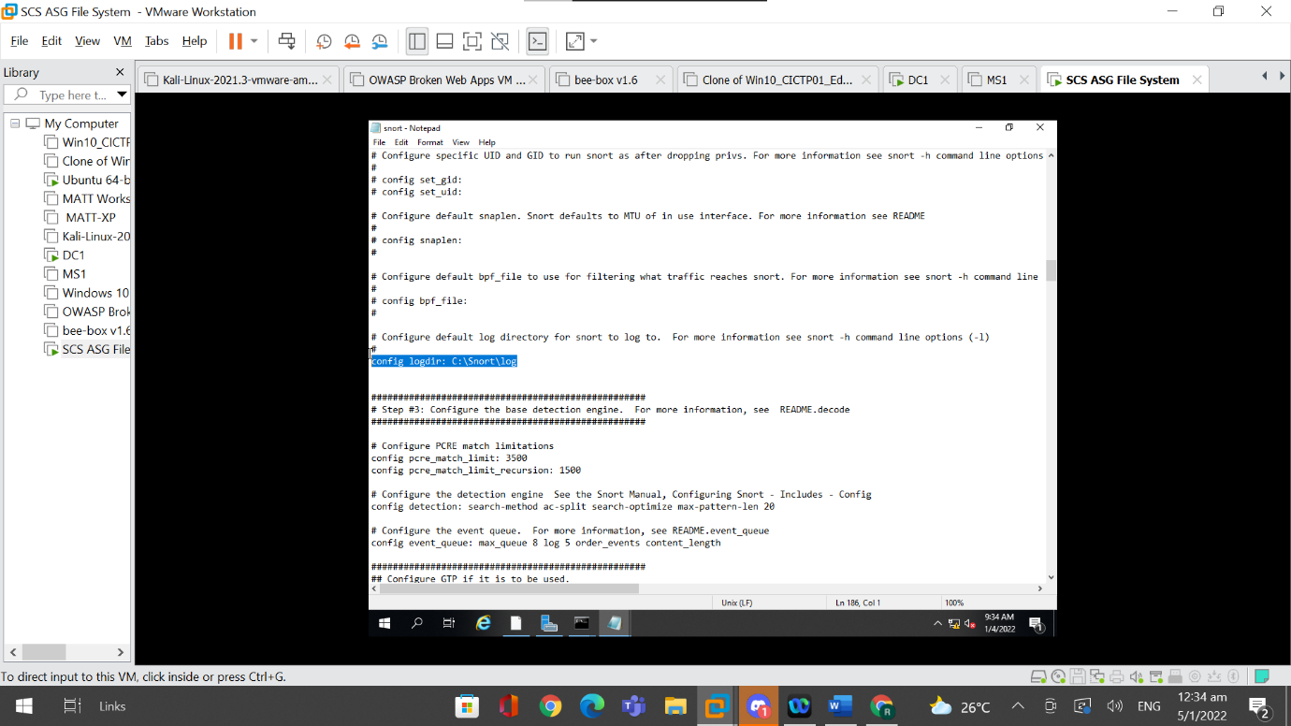

Then I configured the dynamic loaded libraries. I changed the command of “path to dynamic preprocessor libraries” to “dynamicpreprocessor directory C:\Snort\lib\snort_dynamicpreprocessor”, changed the command of “path to base preprocessor engine” to “dynamicengine C:\Snort\lib\snort_dynamicengine\sf_engine.dll”, and commented out the command for “path to dynamic rules libraries”.

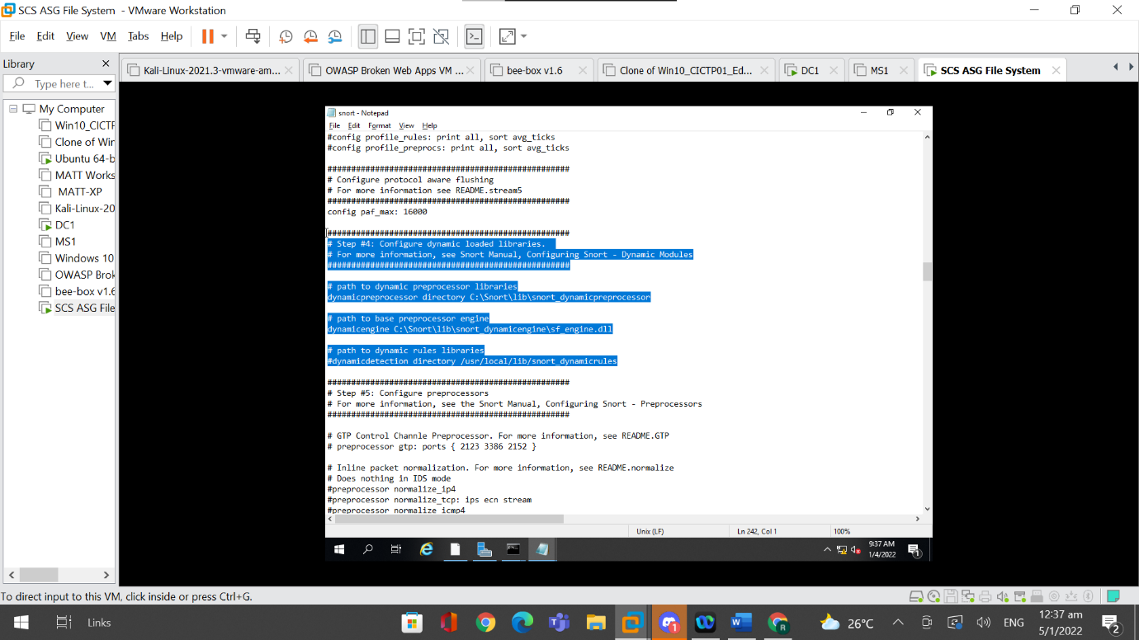

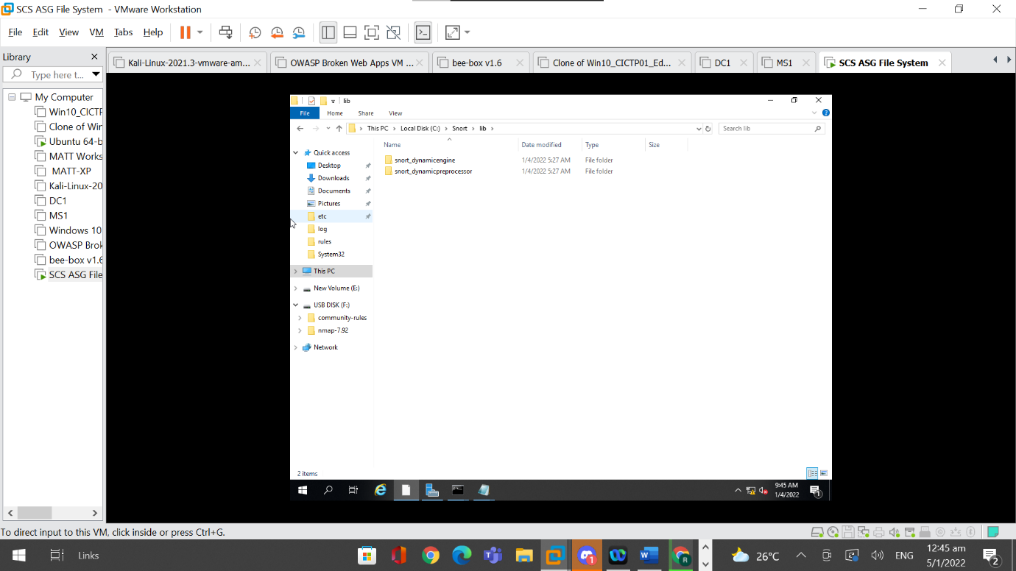

I then created two blank txt files and named it white_list.RULES and black_list.RULES respectively. Then, I had to store these two RULES files into their individual folders. I created two empty folders with the name, “white_list” and “black_list”. Then I changed the config file to have C:\Snort\white_list and C:\Snort\black_list instead.

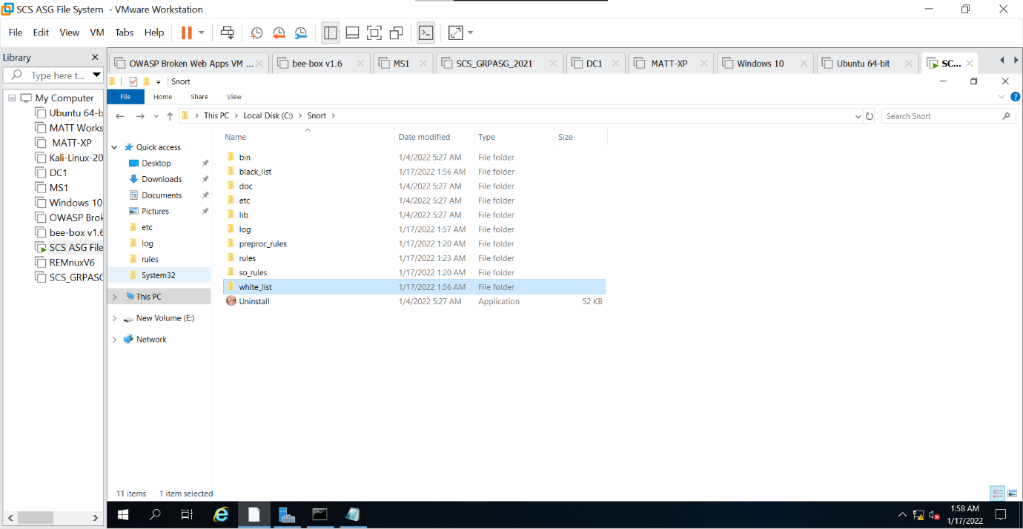

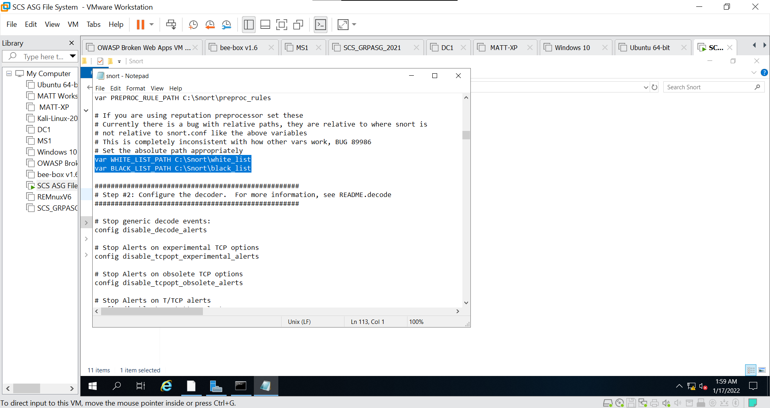

Then I went to edit the rules used by changing each “include” command to use a “\” instead of a “/”. The rules are also changed such that they are the same as the ones named in the rules file.

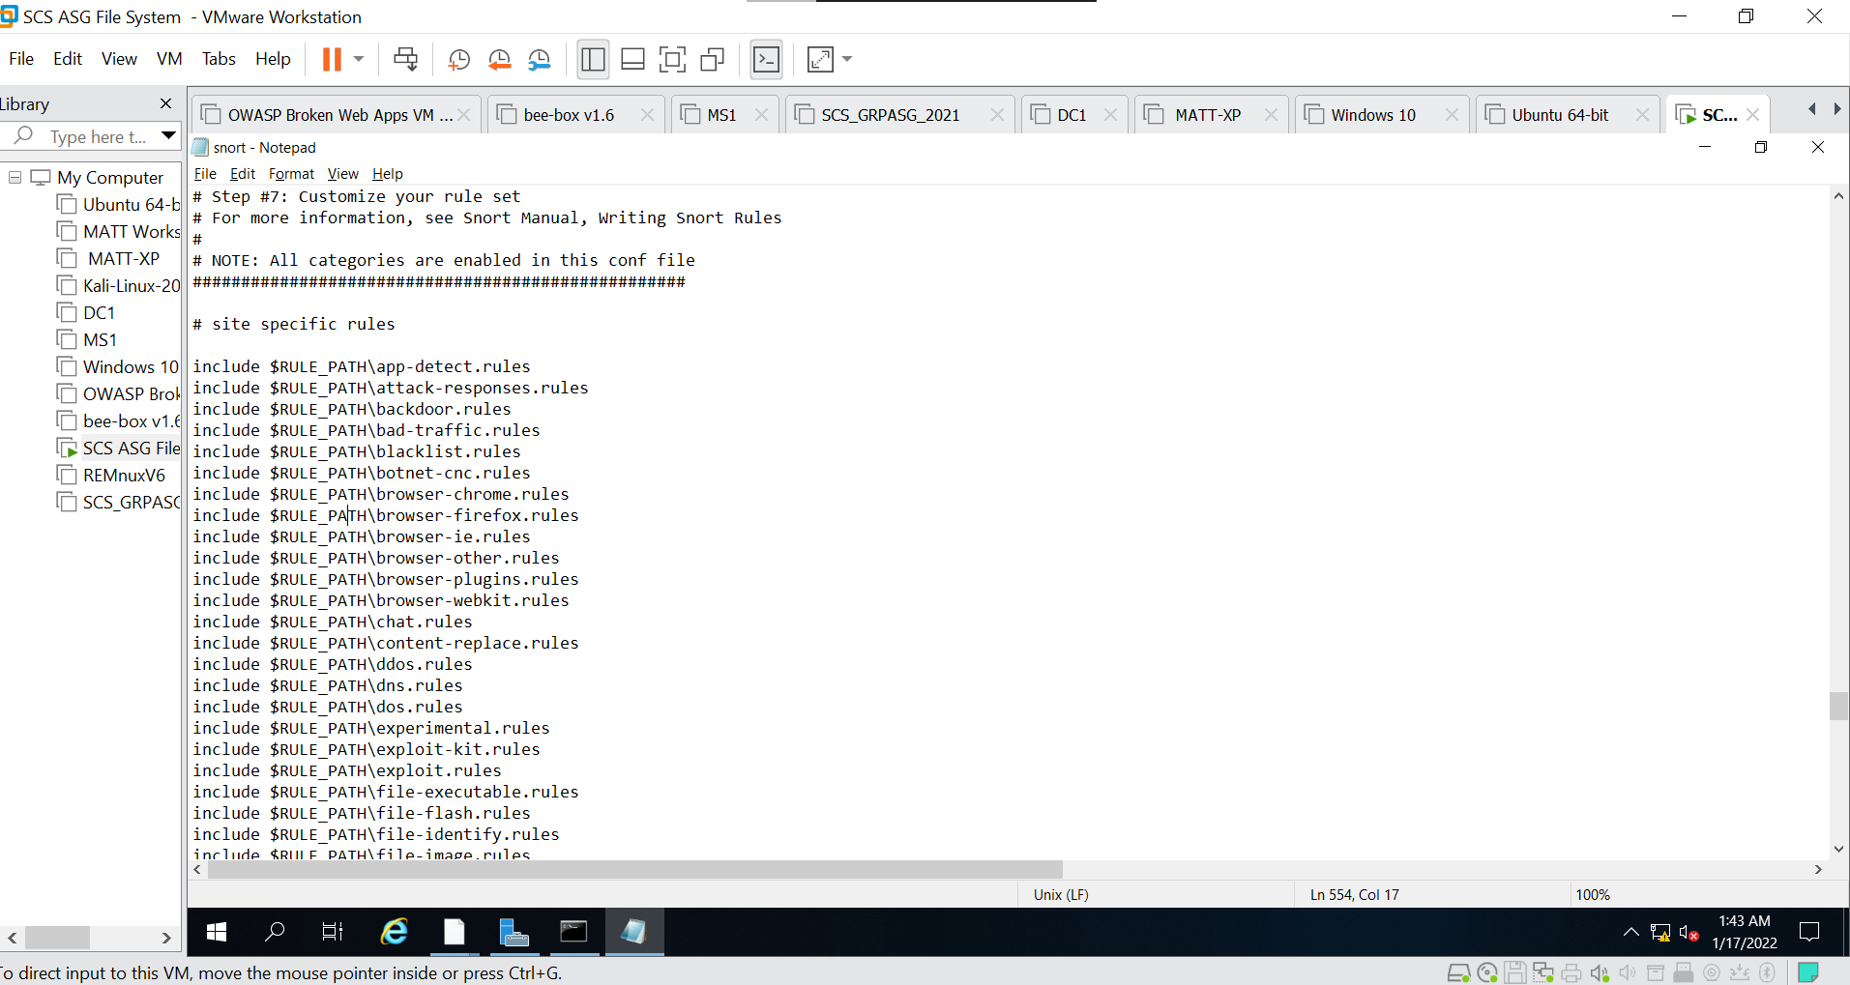



### 4.5.2 Testing Snort

For the testing of Snort, I created my own rules file which captures and logs the alerts of all icmp packets, tcp packets or udp packets that are sent to the File Server. I named the rules file as “testing.RULES”.

I then changed the snort conf file to include the custom set of rules I had created and commented out the rest of the rules in the conf file so as to prevent any overlap of data capture.

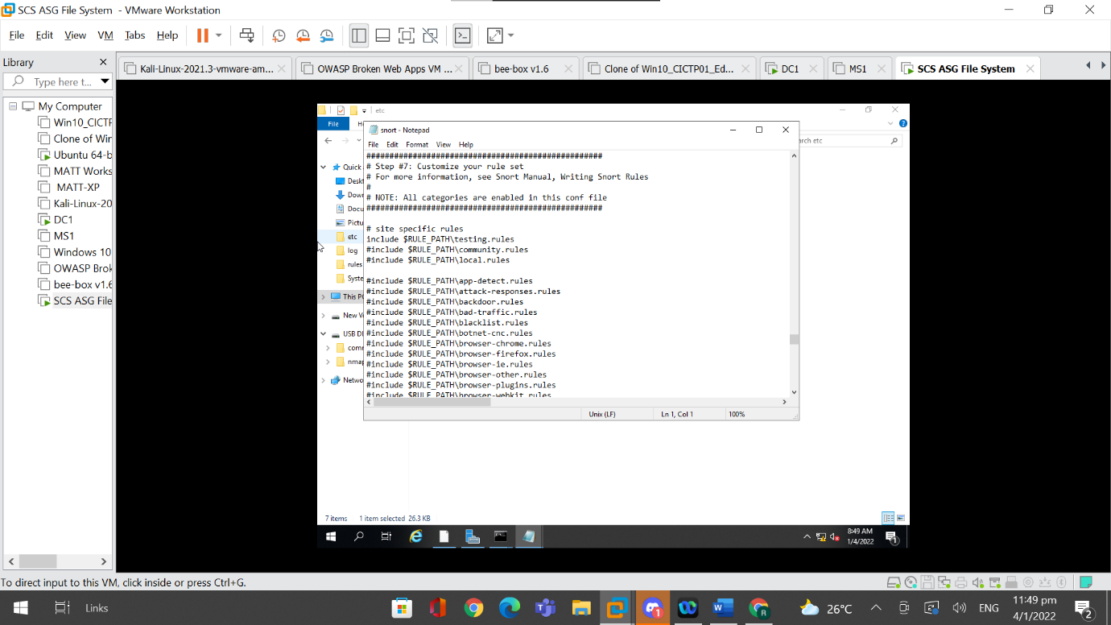

I used the command, “Snort -V” to check the version of Snort and to ensure that Snort has been installed correctly and is working as intended.

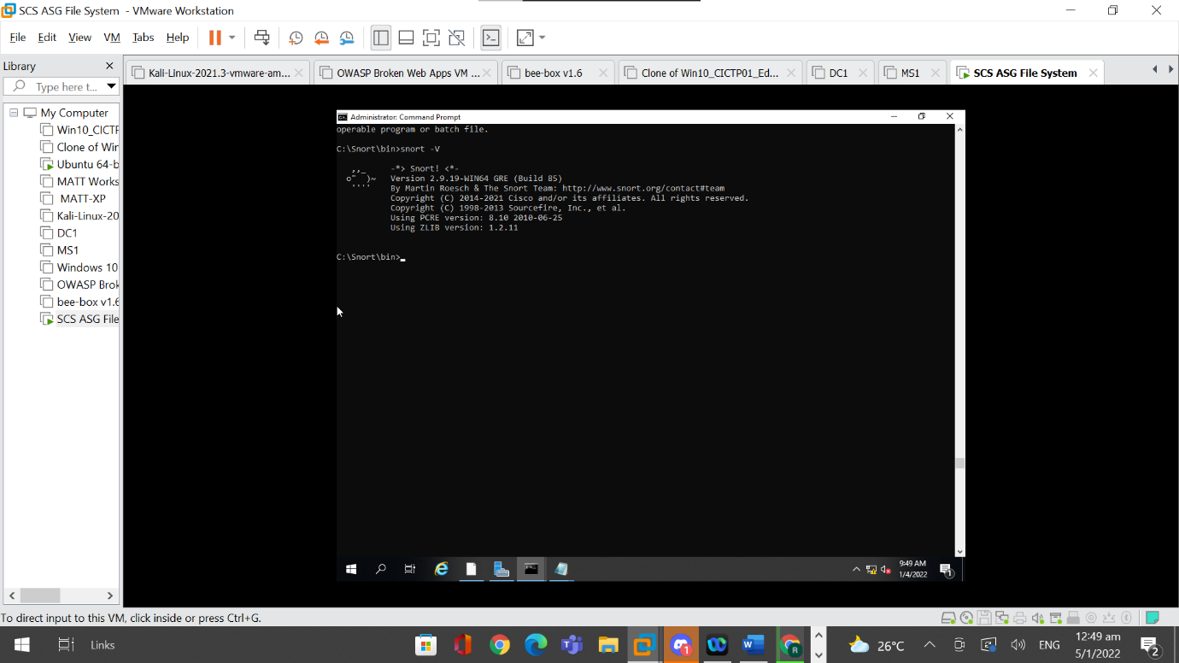

I used the command, “Snort.exe -W”, to identify which interface to use.

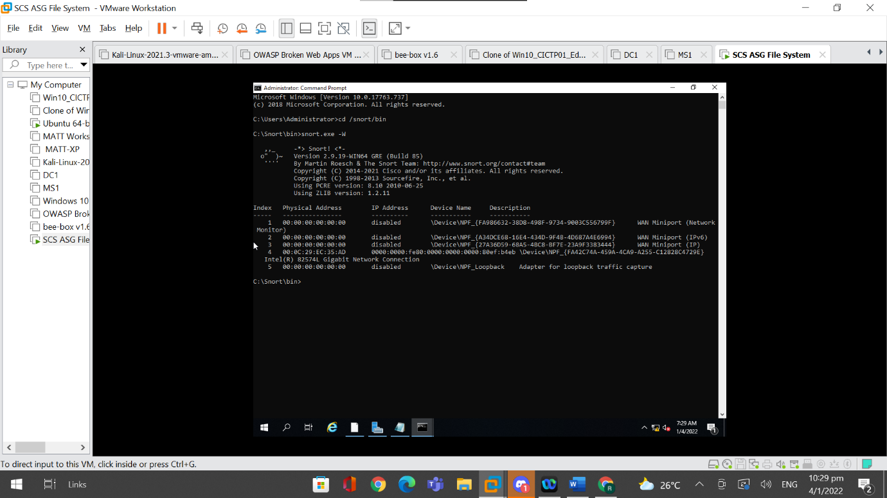

Then, I change to the directory of the libraries of snort through the command of “cd /snort/bin”. Then, I used the command, “snort -i 4 -c C:\Snort\etc\snort.conf -A console > C:\Snort\log\pingtest.txt”. These commands make it such that it listens on interface 4 and locates the snort conf file to use the rules specified in it, which will be “testing.RULES”. Snort then captures the alerts made and writes it to a text file in C:\Snort\log.

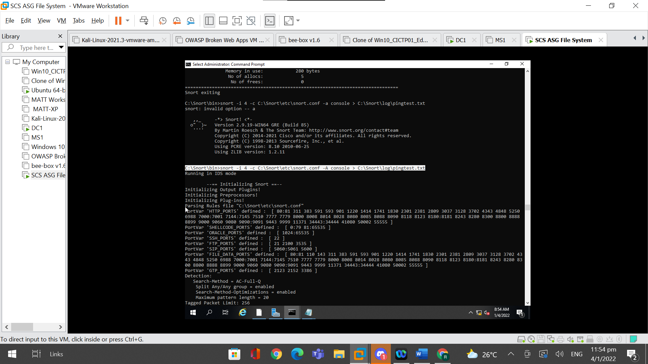

After running the command, “Commencing packet processing” will be seen and one has to wait awhile before clicking on “ctrl c” to end the packet processing. All traffic that was from the Virtual Machine that is either a ICMP, TCP or UDP packet will be noted and logged in a file called, “pingtest.txt”.

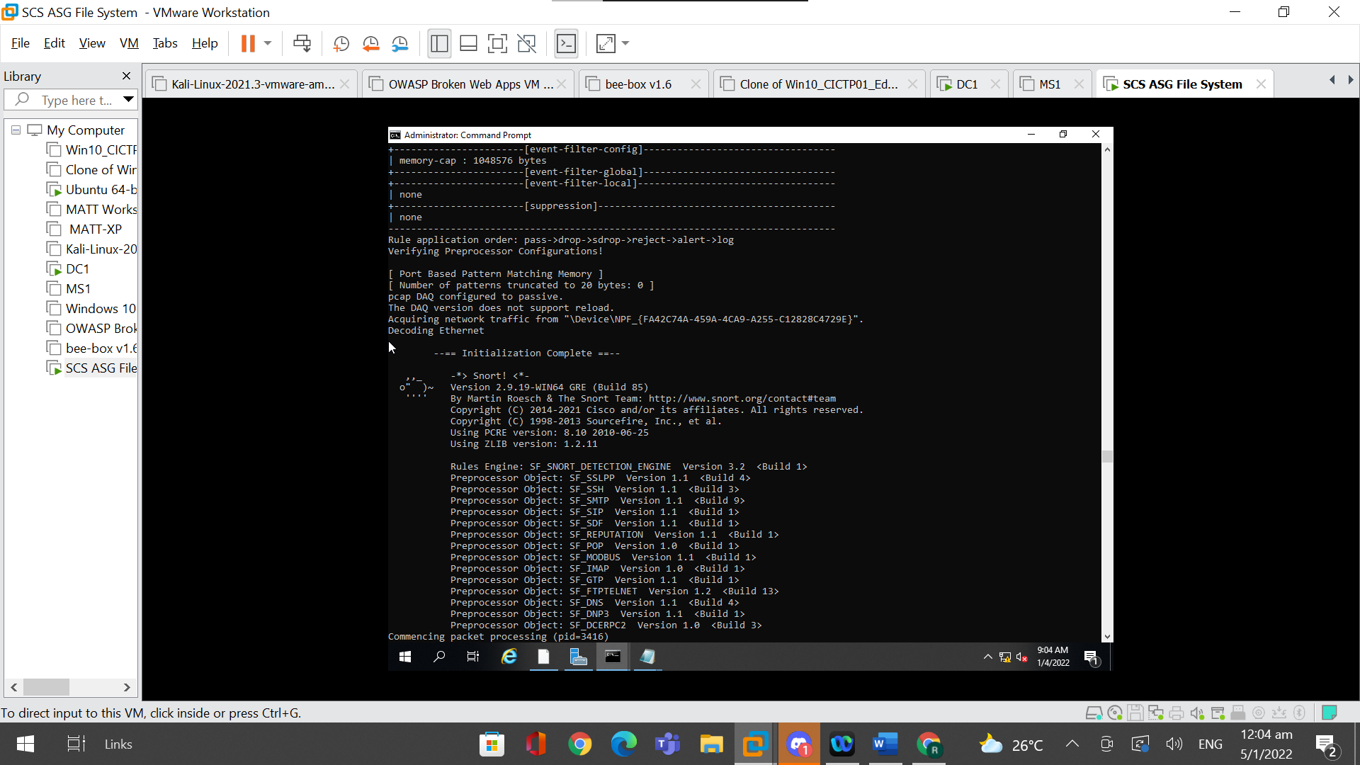

After stopping the command, we can see that the text file, “pingtest” is created inside C:\Snort\log.

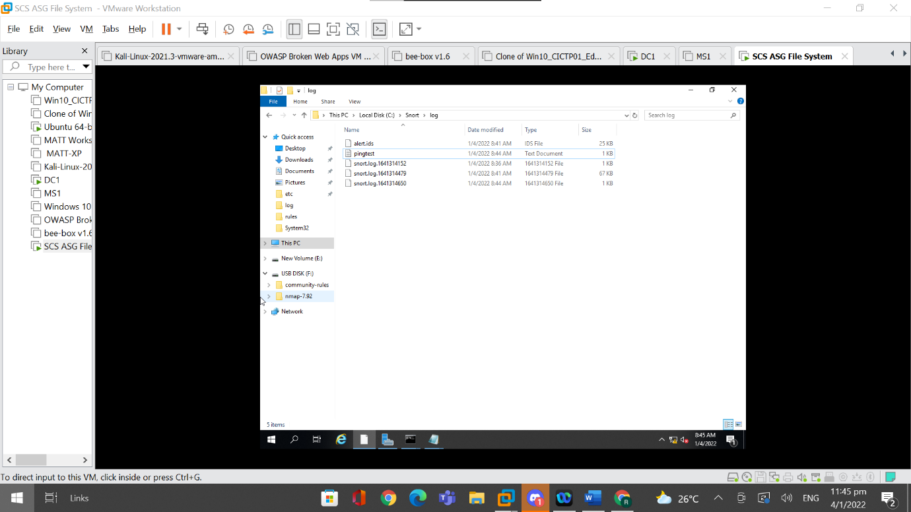

If we open the text file, we can see the ICMP, TCP, and UDP traffic that was transmitted by the file server. Thus, Snort is able to monitor the traffic being sent by the server and is able to log these traffics based on the rules configured, making it a successful IDS.

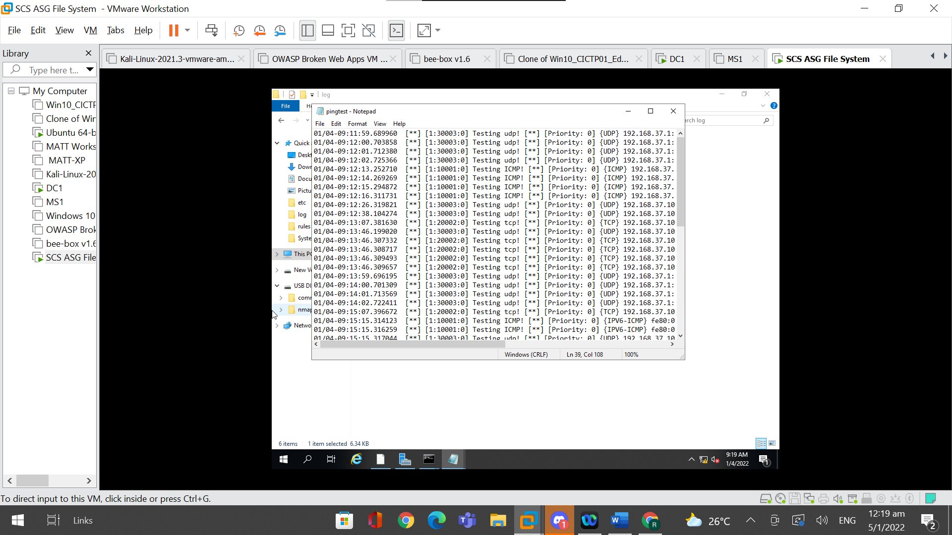

Although Snort was not configured to run in the background automatically to monitor the network constantly. The command, “snort -i 4 -c C:\Snort\etc\snort.conf -A console > C:\Snort\log\pingtest.txt” can be used so that snort is runned in the background to monitor the network consistently. This command can be stopped at the end of the day or at the end of the week manually. Whenever the command ends, the command should be used again but the logs should be saved to a different file. Proper naming schemes of the log files should also be used for organisational purposes. Although this requires more administrative effort, this can make the logs captured more organised as it is already separated based on weeks or days.